Binyah BP Creation

Home - Personal - Microsoft​ Edge

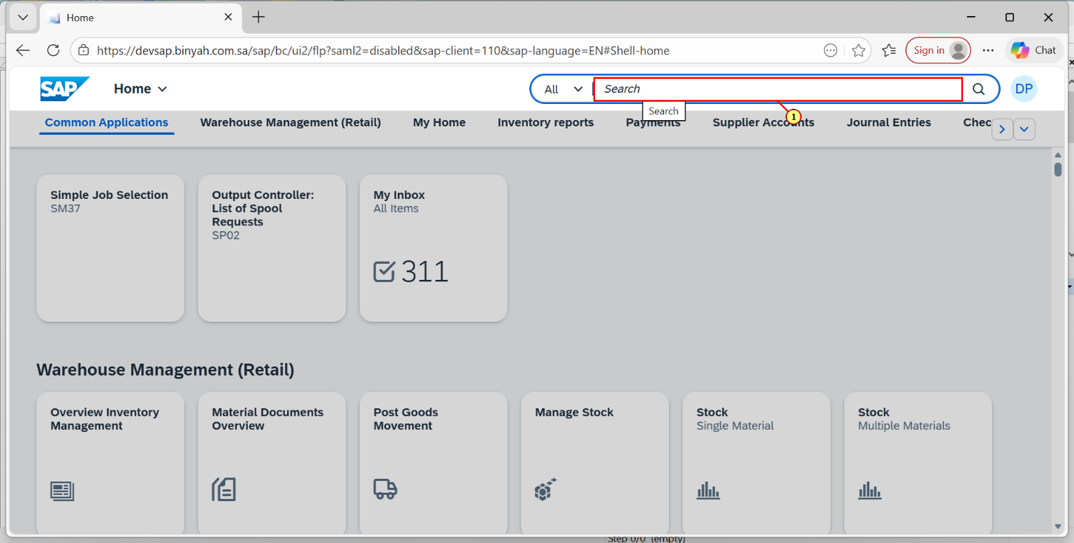

| Step | Action |
| --- | --- |
| (1) | Enter "Maintain Business Partner". |

Home - Personal - Microsoft​ Edge

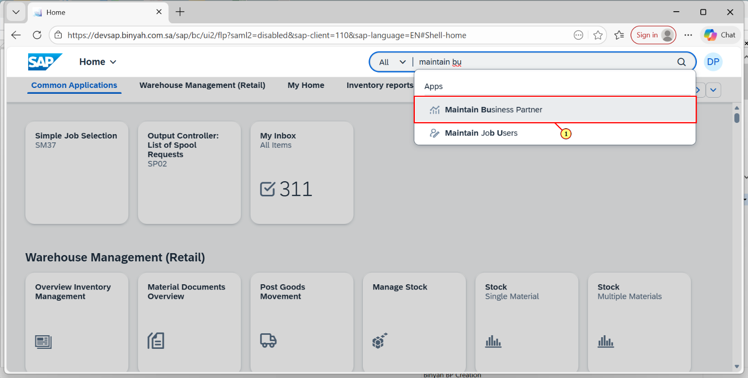

| Step | Action |
| --- | --- |
| (1) | Click  Maintain Business Partner**.** |

Maintain Business Partner - Personal - Microsoft​ Edge

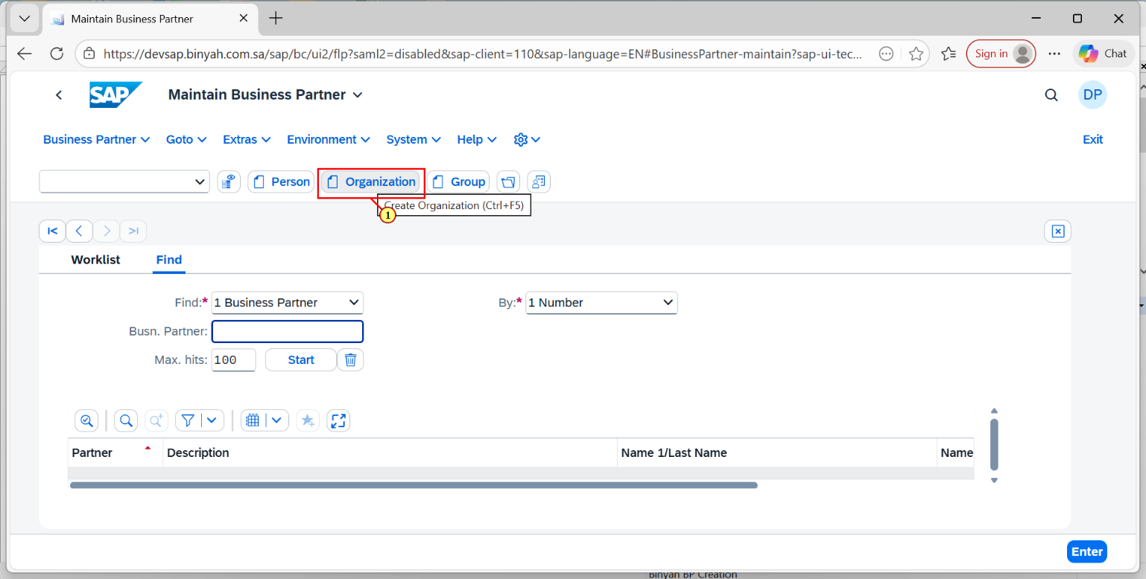

| Step | Action |
| --- | --- |
| (1) | Click On Organization. |

Create Organization - Personal - Microsoft​ Edge

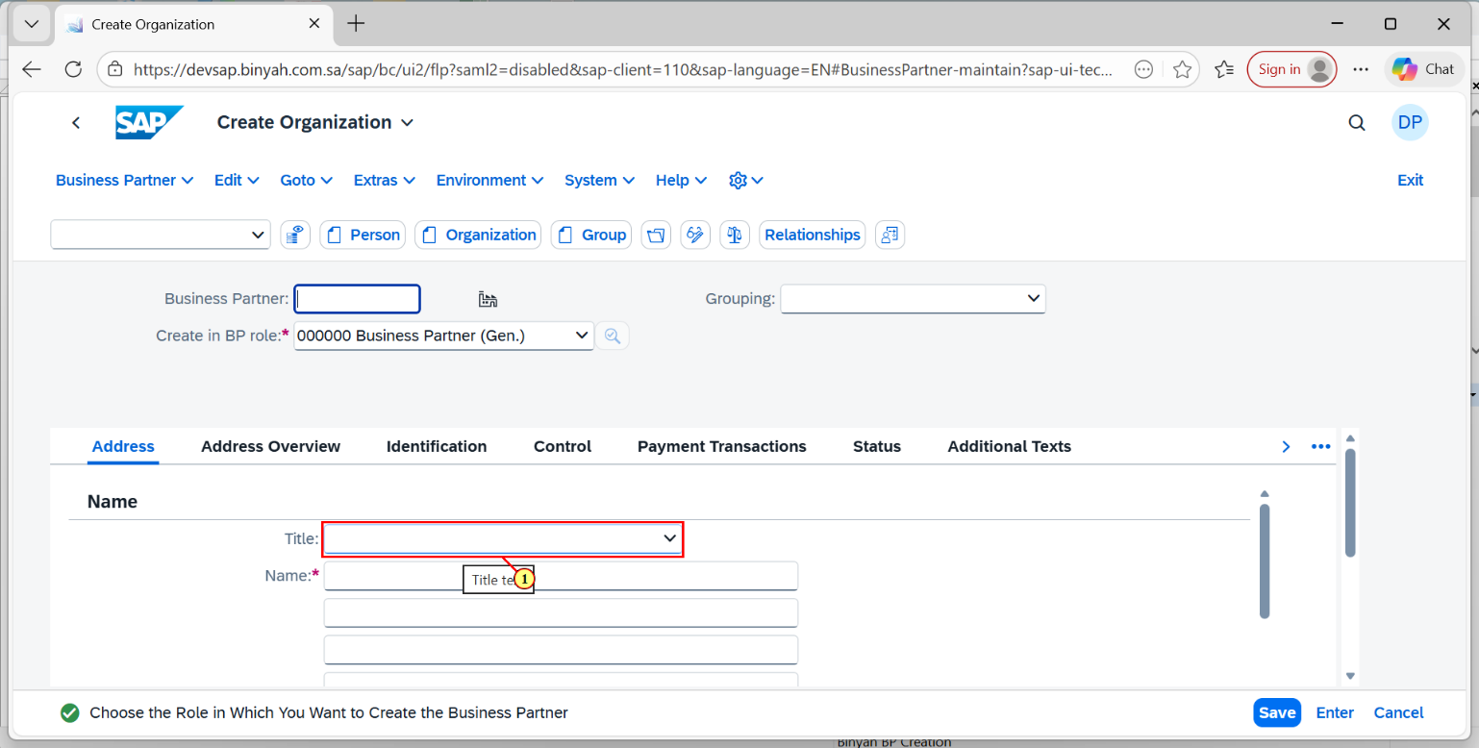

| Step | Action |
| --- | --- |
| (1) | Click on Title Dropdown menu and select "Company 0003". |

Create Organization - Personal - Microsoft​ Edge

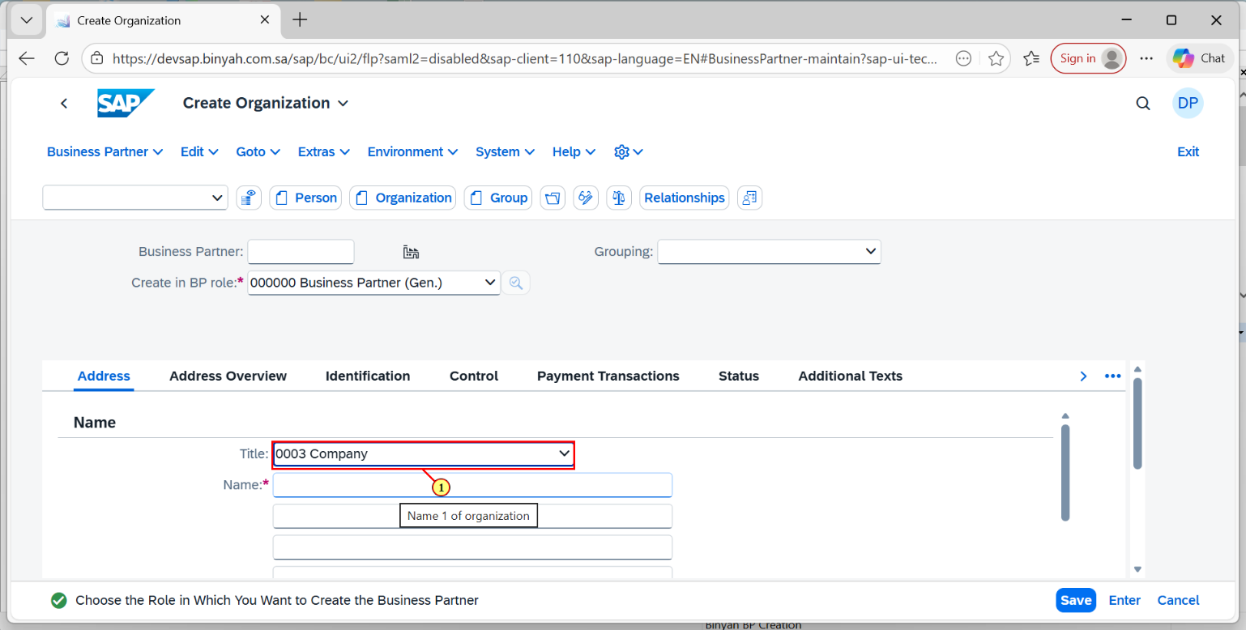

| Step | Action |
| --- | --- |
| (1) | Click Enter to fill "0003 Company". |

Create Organization - Personal - Microsoft​ Edge

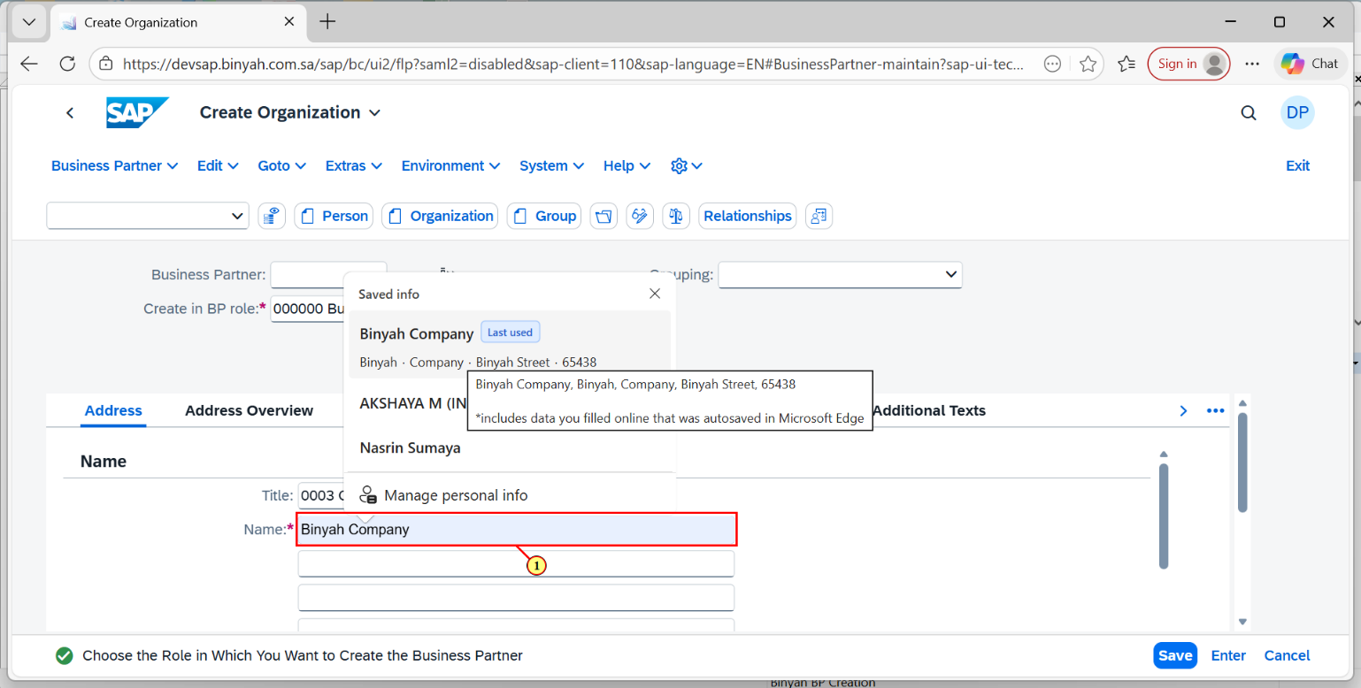

| Step | Action |
| --- | --- |
| (1) | Enter the Name of the Company and click Enter. |

Create Organization - Personal - Microsoft​ Edge

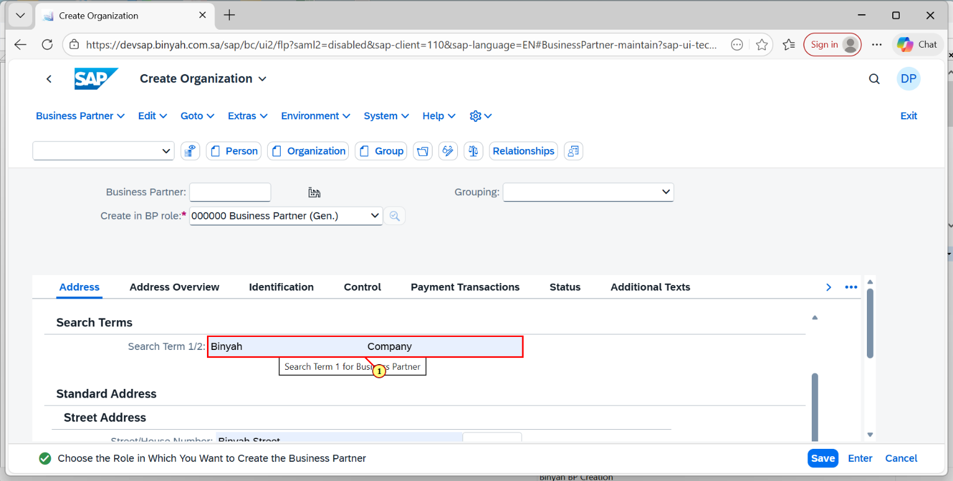

| Step | Action |
| --- | --- |
| (1) | Click on Search Term Box and Click Enter. |

Create Organization - Personal - Microsoft​ Edge

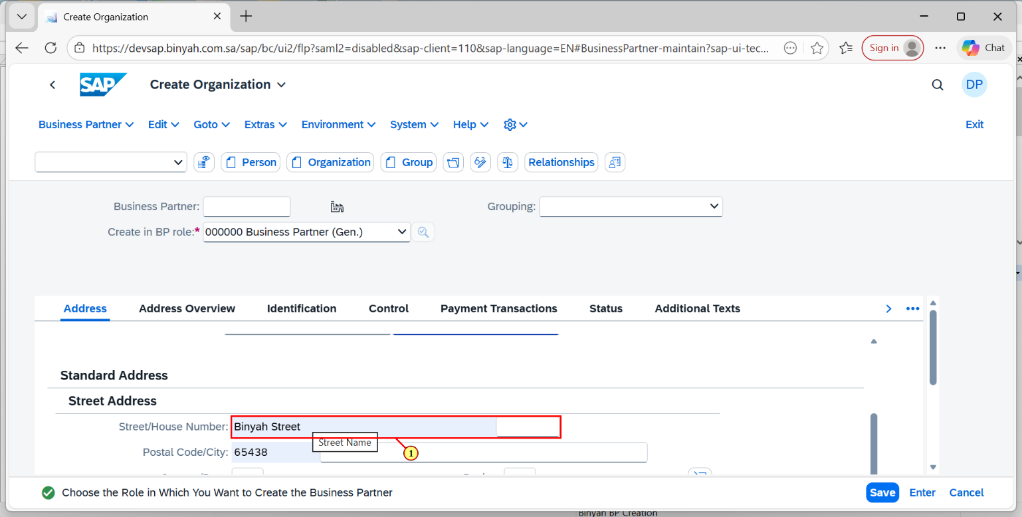

| Step | Action |
| --- | --- |
| (1) | Enter the Street and House Number detail. |

Create Organization - Personal - Microsoft​ Edge

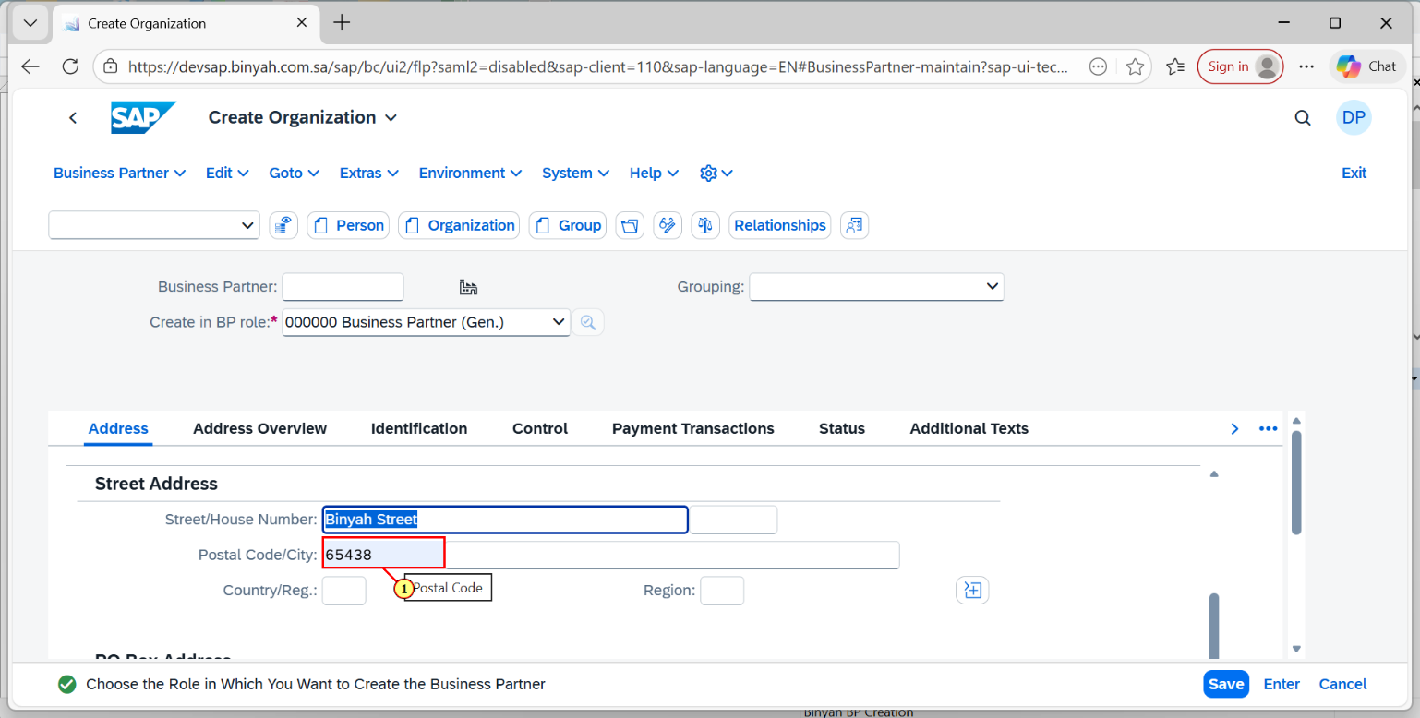

| Step | Action |
| --- | --- |
| (1) | Enter Postal Code. |

Create Organization - Personal - Microsoft​ Edge

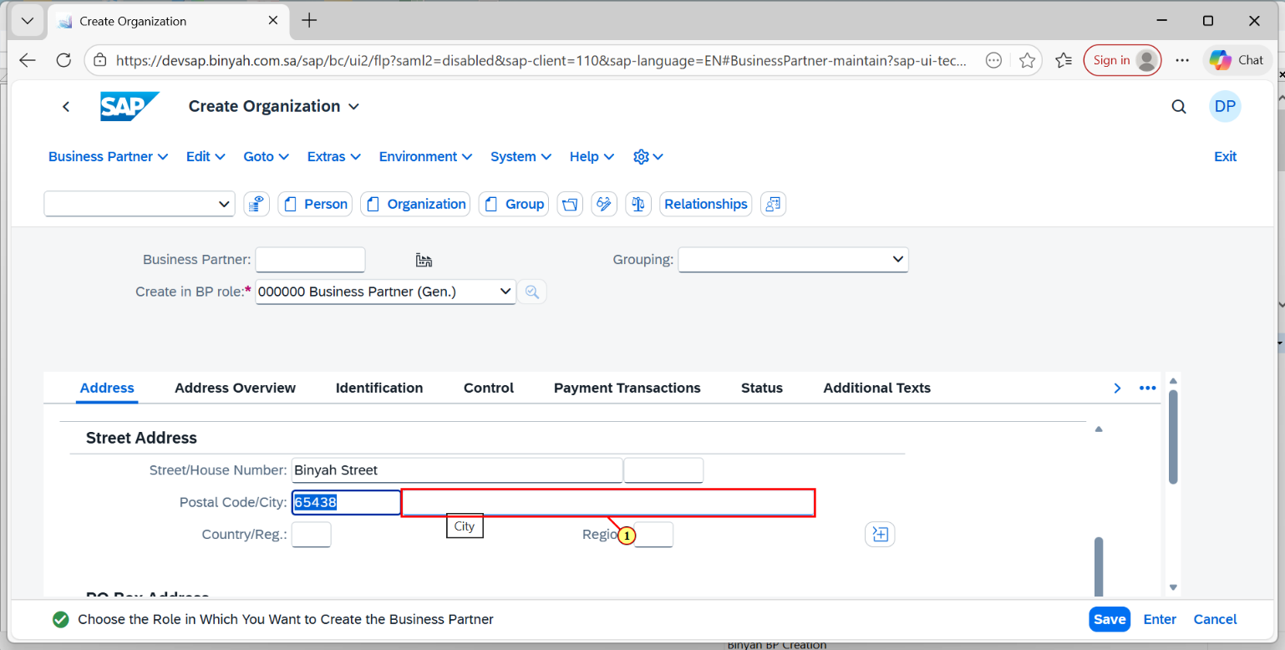

| Step | Action |
| --- | --- |
| (1) | Enter the City and Click "OK". |

Create Organization - Personal - Microsoft​ Edge

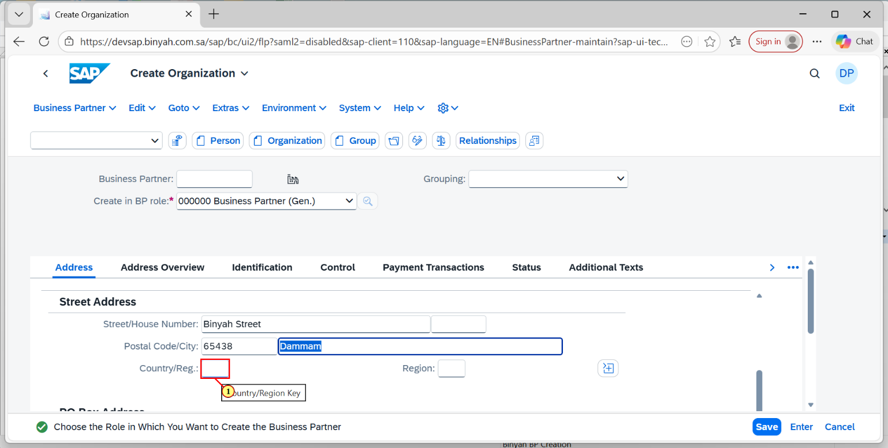

| Step | Action |
| --- | --- |
| (1) | Use Search help enter the Country/Reg. |

Create Organization - Personal - Microsoft​ Edge

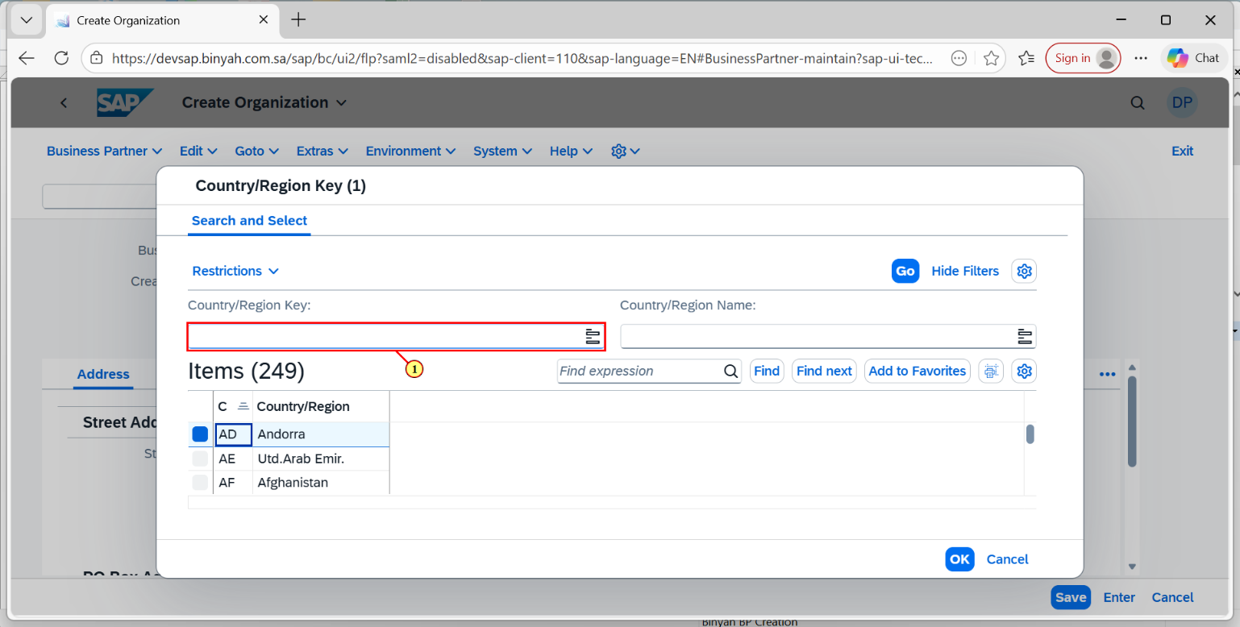

| Step | Action |
| --- | --- |
| (1) | Select the item. |

Create Organization - Personal - Microsoft​ Edge

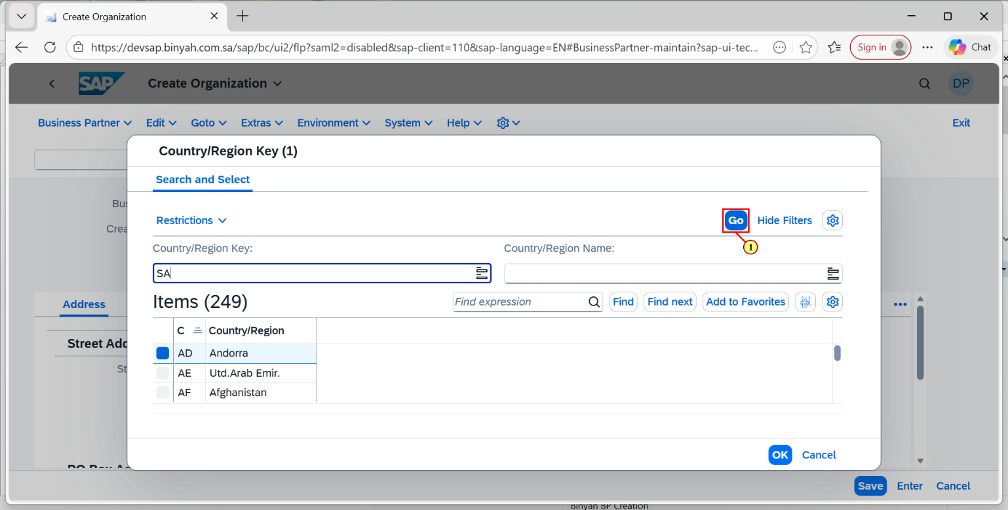

| Step | Action |
| --- | --- |
| (1) | Click on "GO". |

Create Organization - Personal - Microsoft​ Edge

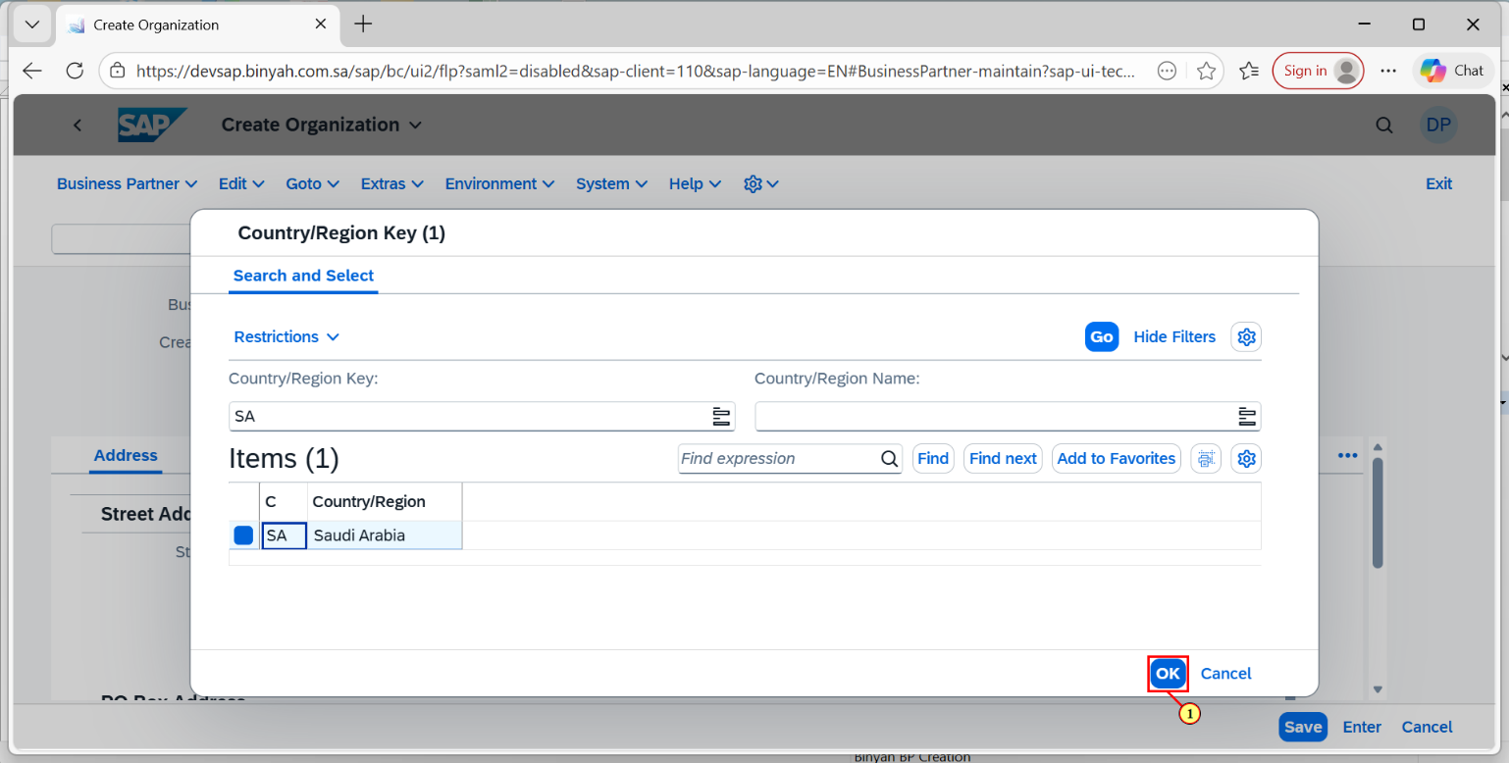

| Step | Action |
| --- | --- |
| (1) | Click "OK". |

Create Organization - Personal - Microsoft​ Edge

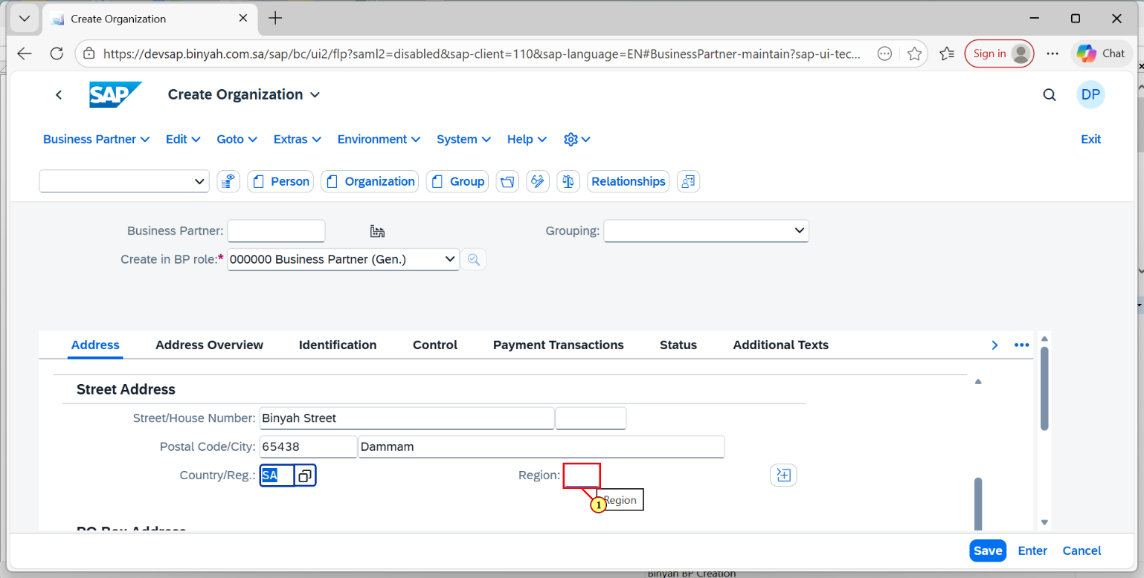

| Step | Action |
| --- | --- |
| (1) | Enter the Region by the using Search help. |

Create Organization - Personal - Microsoft​ Edge

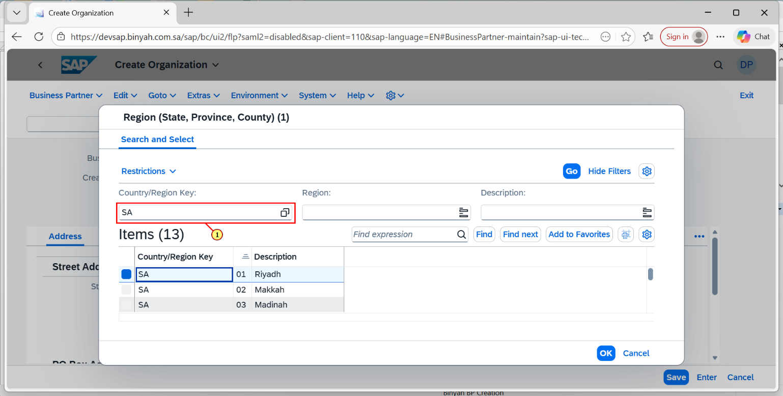

| Step | Action |
| --- | --- |
| (1) | Enter the Search Terms and then Click on "GO". |

Create Organization - Personal - Microsoft​ Edge

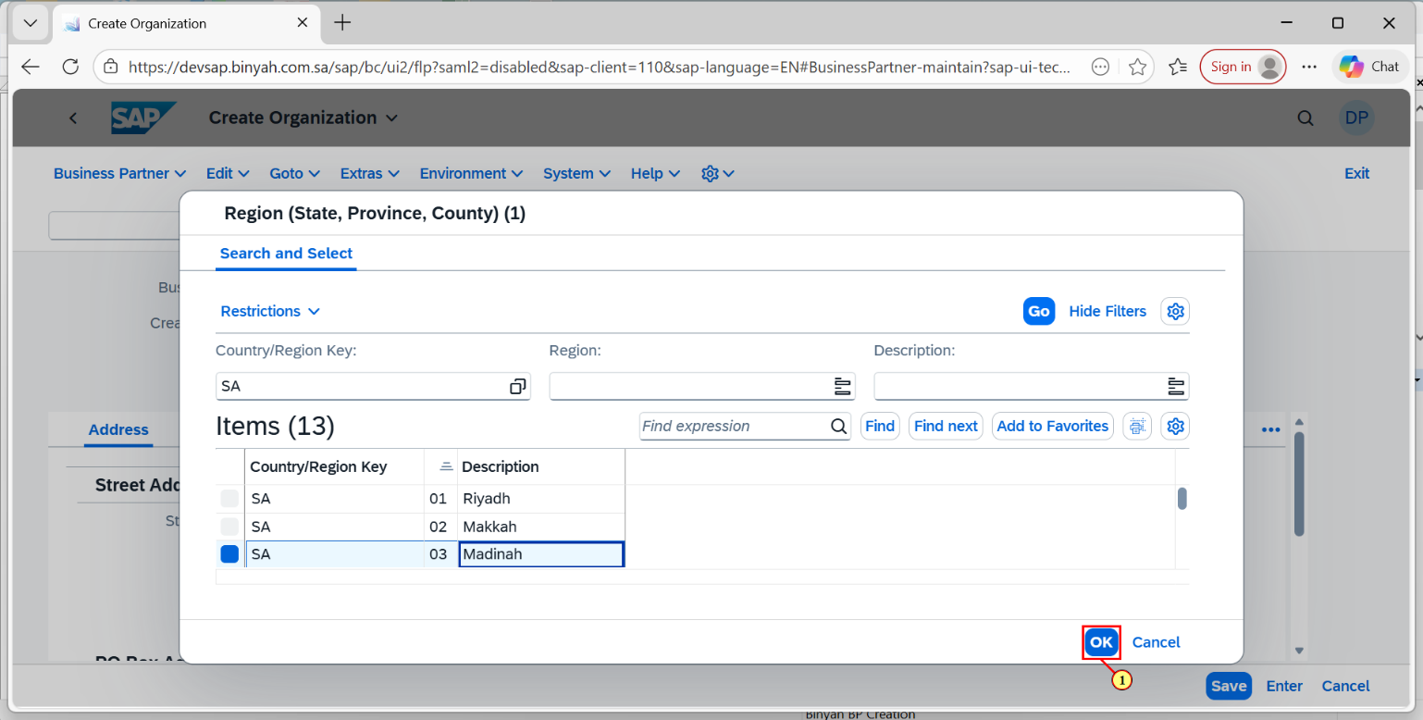

| Step | Action |
| --- | --- |
| (1) | Click on "OK". |

Create Organization - Personal - Microsoft​ Edge

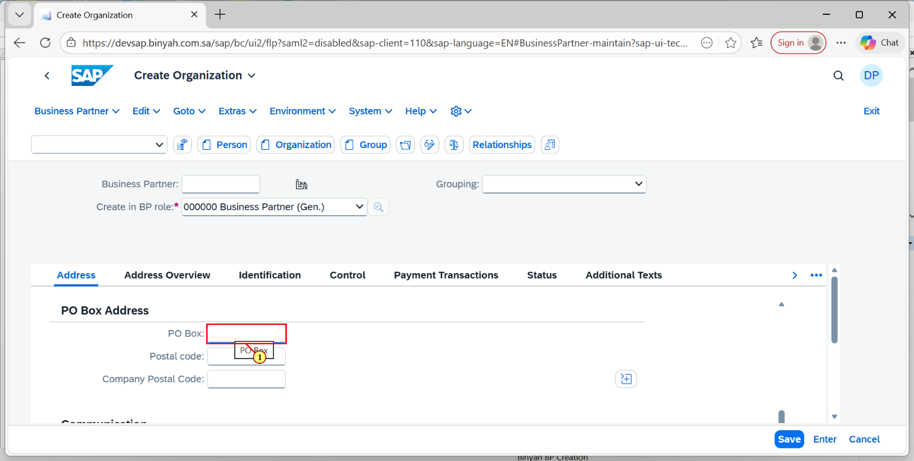

| Step | Action |
| --- | --- |
| (1) | Enter the PO Box Number. |

Create Organization - Personal - Microsoft​ Edge

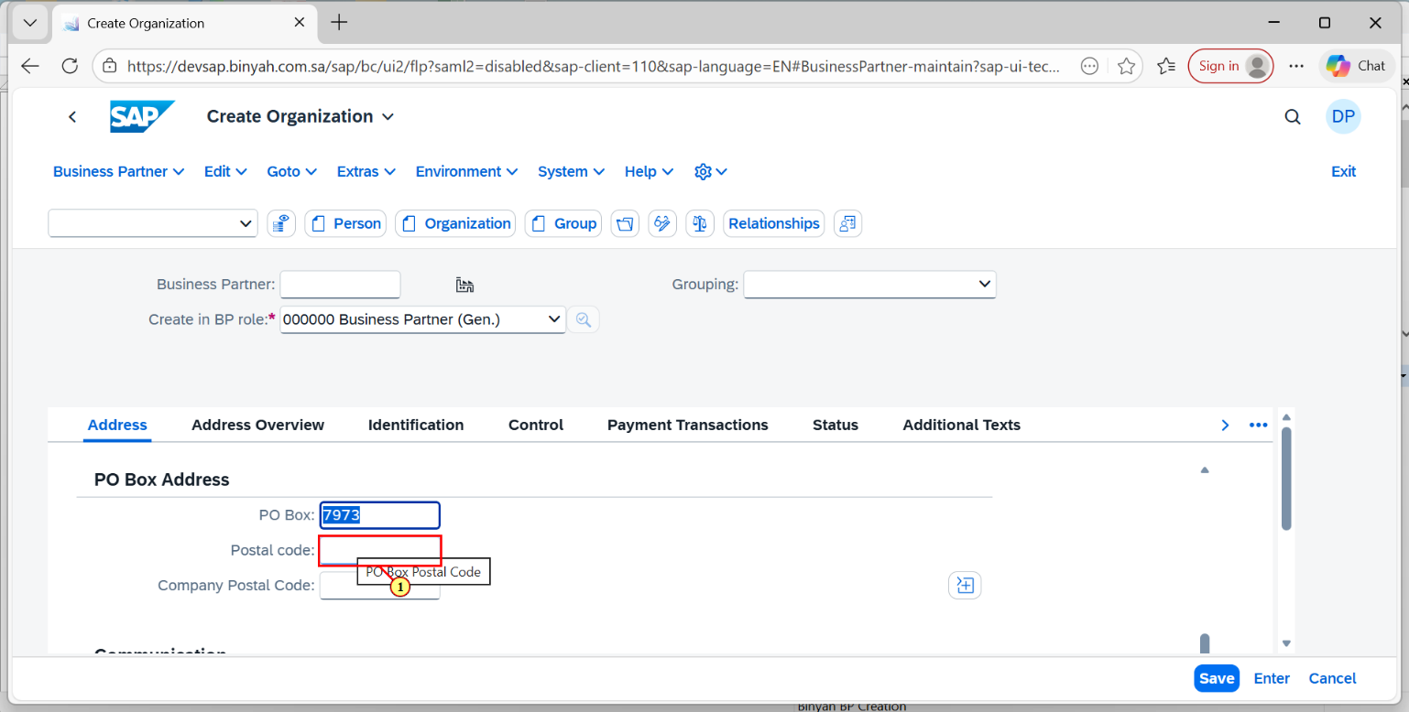

| Step | Action |
| --- | --- |
| (1) | Enter the Postal code number. |

Create Organization - Personal - Microsoft​ Edge

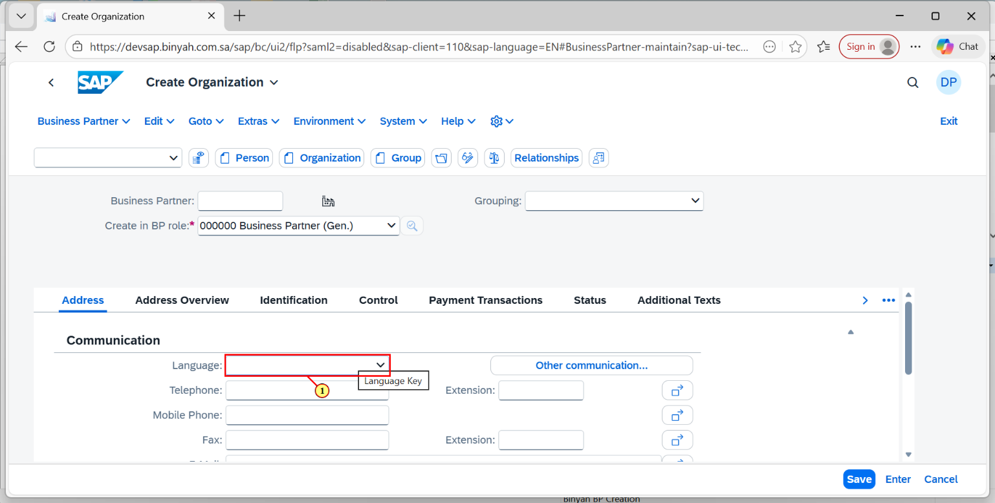

| Step | Action |
| --- | --- |
| (1) | Click On Language Search Help. |

Create Organization - Personal - Microsoft​ Edge

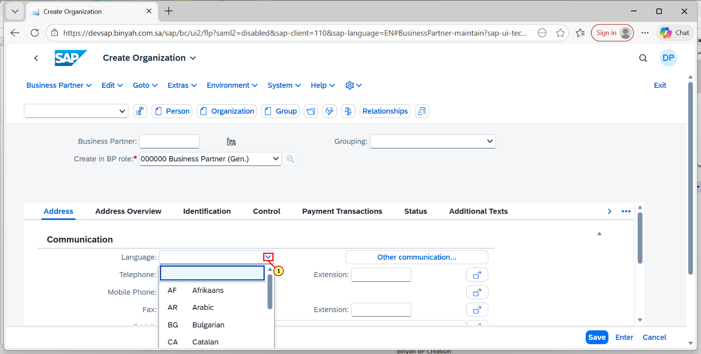

| Step | Action |
| --- | --- |
| (1) | Select the Language. |

Create Organization - Personal - Microsoft​ Edge

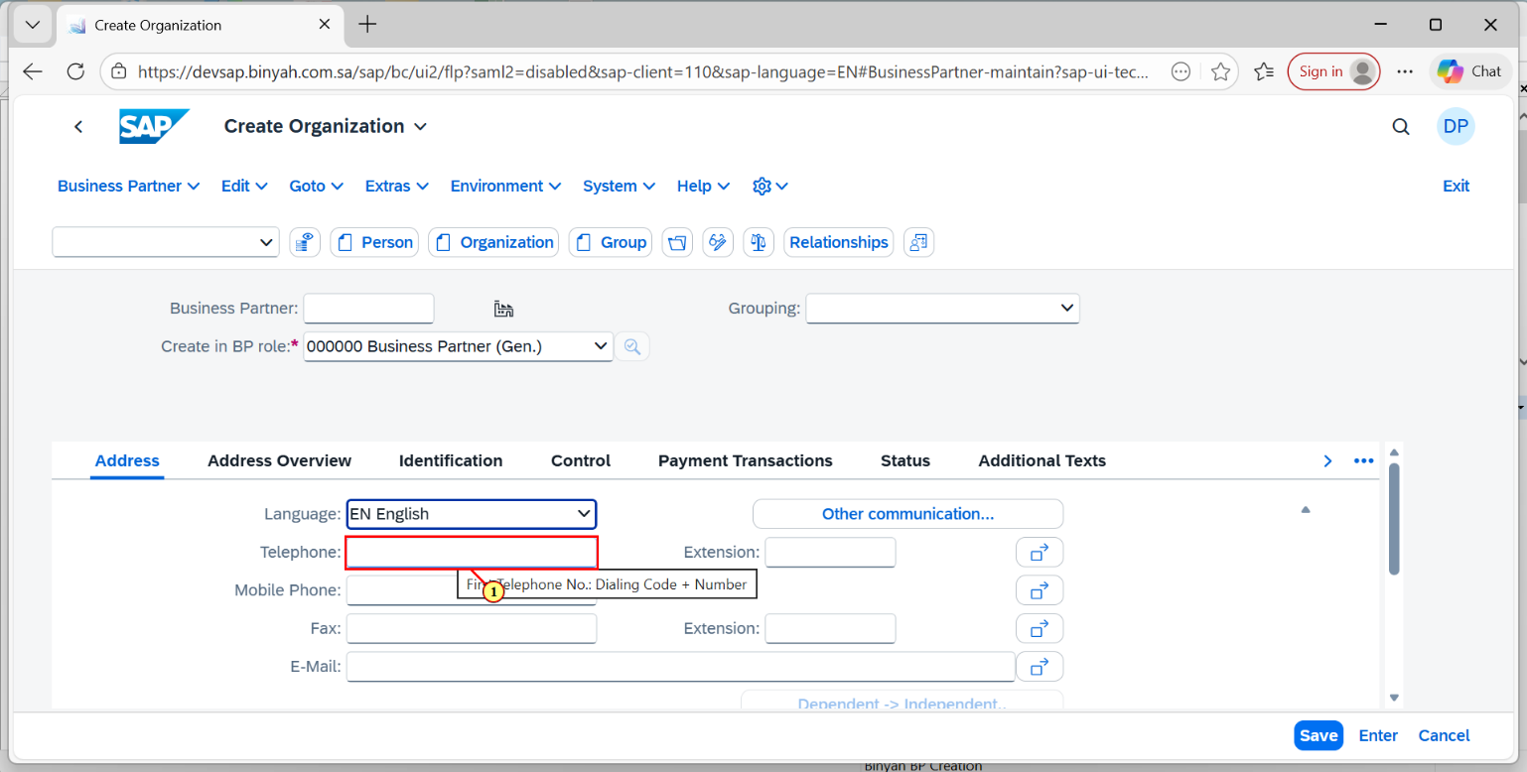

| Step | Action |
| --- | --- |
| (1) | Enter the Telephone Number. |

Create Organization - Personal - Microsoft​ Edge

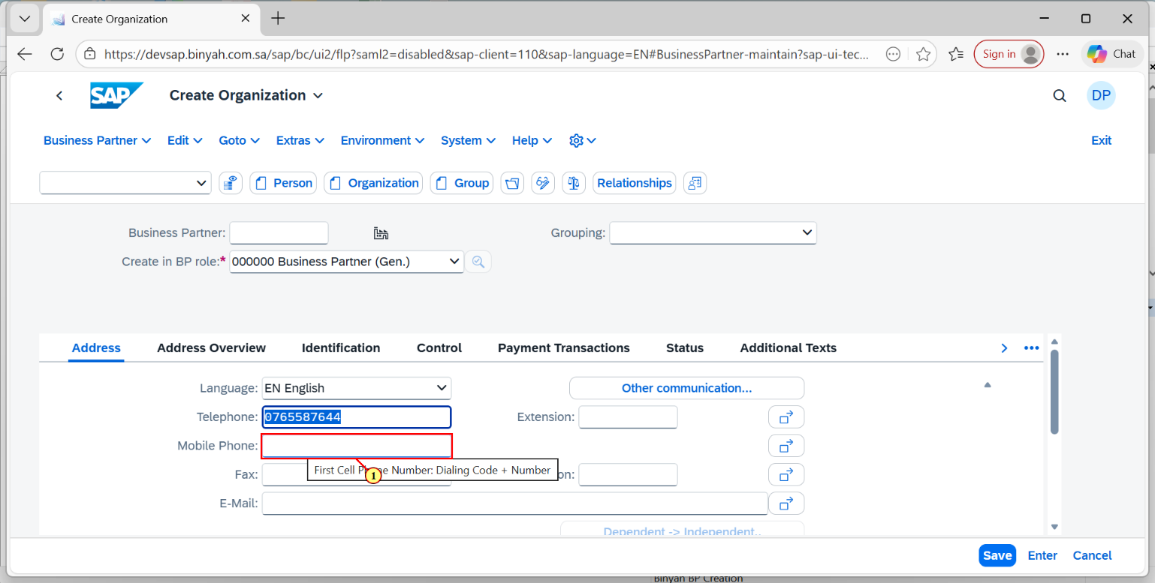

| Step | Action |
| --- | --- |
| (1) | Enter the Mobile Number. |

Create Organization - Personal - Microsoft​ Edge

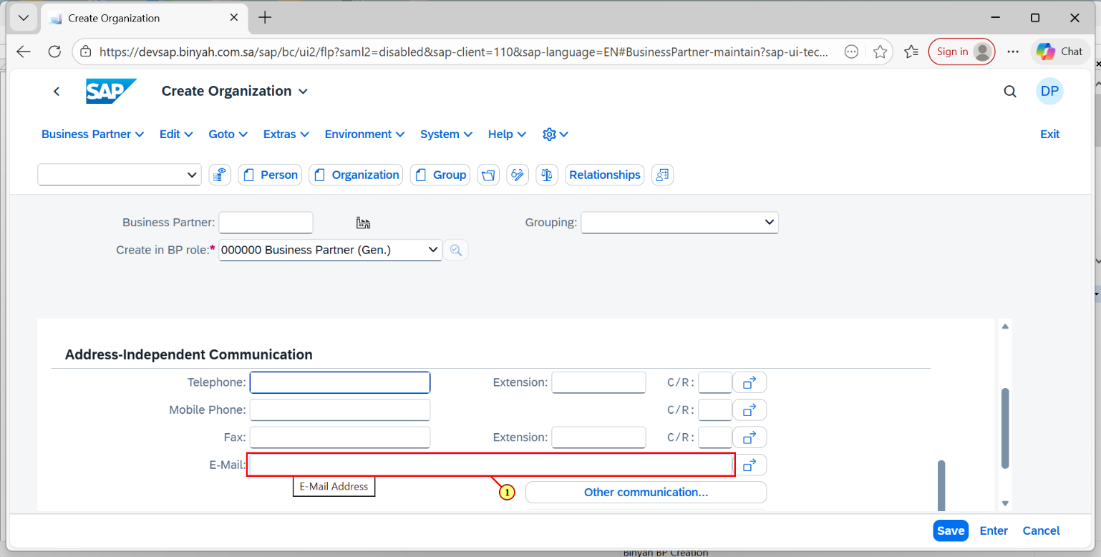

| Step | Action |
| --- | --- |
| (1) | Enter the E-Mail Id. |

Create Organization - Personal - Microsoft​ Edge

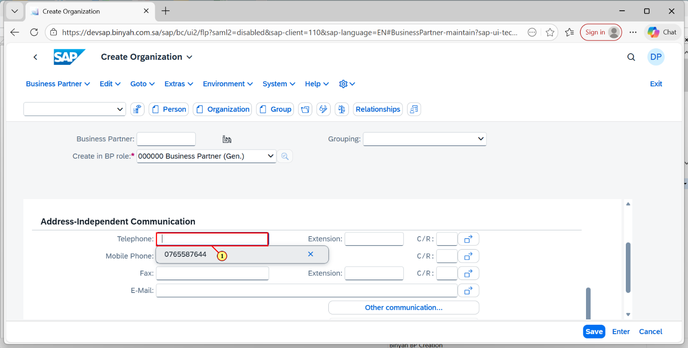

| Step | Action |
| --- | --- |
| (1) | Click on Telephone field and Enter the Number. |

Create Organization - Personal - Microsoft​ Edge

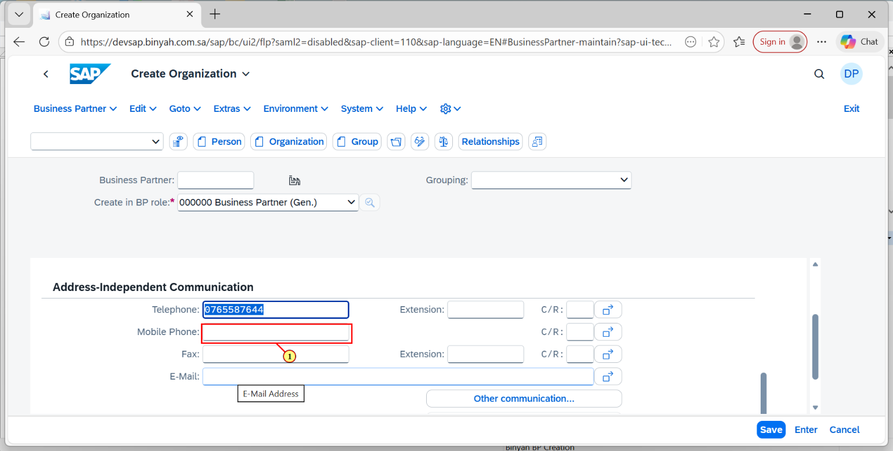

| Step | Action |
| --- | --- |
| (1) | Enter the Mobile Number. |

Create Organization - Personal - Microsoft​ Edge

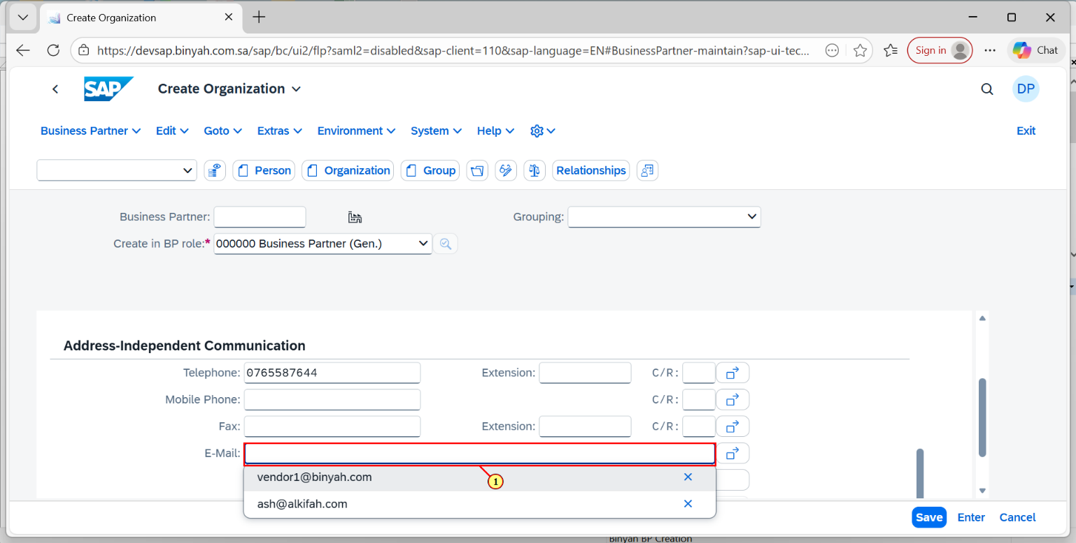

| Step | Action |
| --- | --- |
| (1) | Click on the E-Mail Id and Enter the ID. |

Create Organization - Personal - Microsoft​ Edge

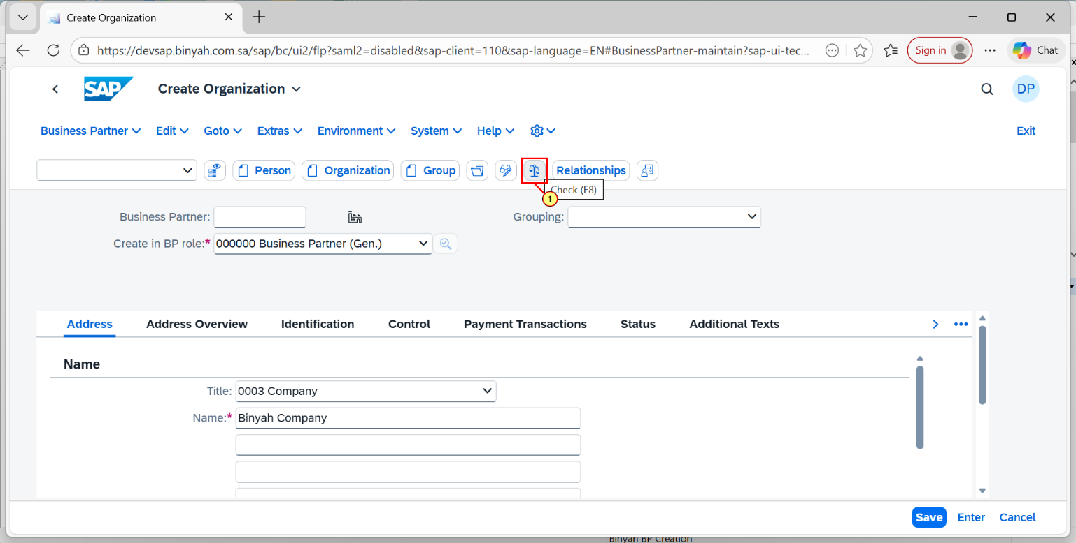

| Step | Action |
| --- | --- |
| (1) | Click on "Check". |

Create Organization - Personal - Microsoft​ Edge

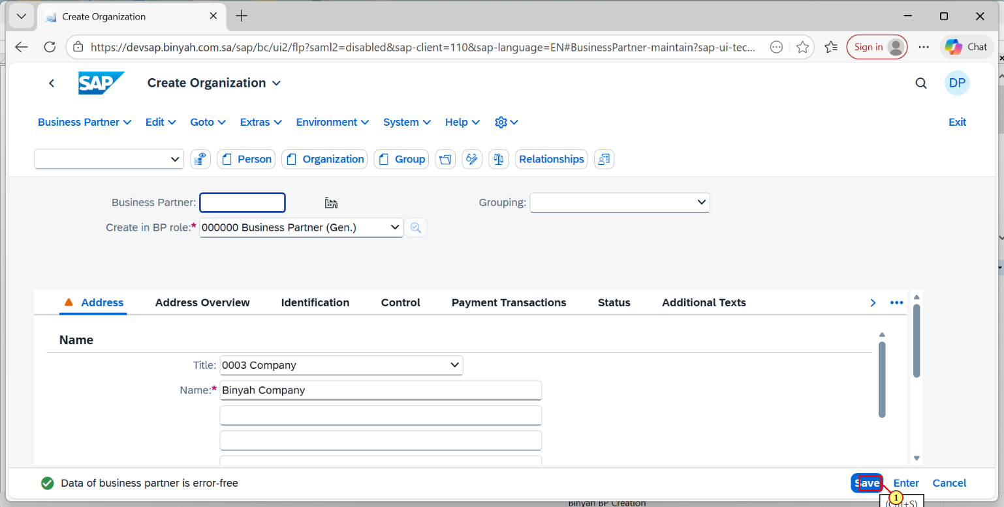

| Step | Action |
| --- | --- |
| (1) | Click on "Save". |

Display Organization : 11 - Personal - Microsoft​ Edge

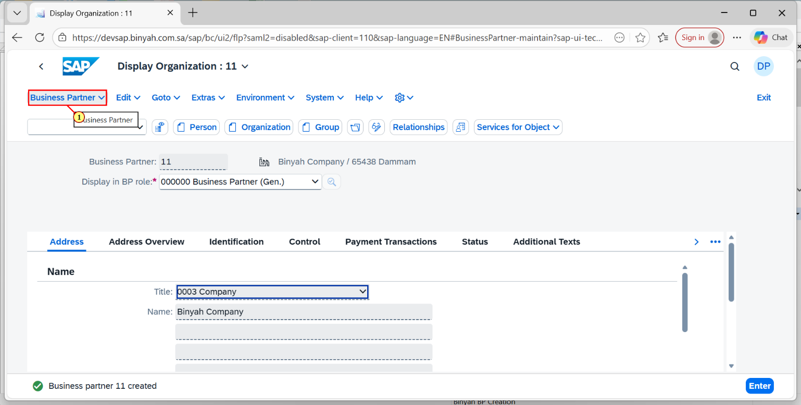

| Step | Action |
| --- | --- |
| (1) | Now click on Business Partner dropdown. |

Display Organization : 11 - Personal - Microsoft​ Edge

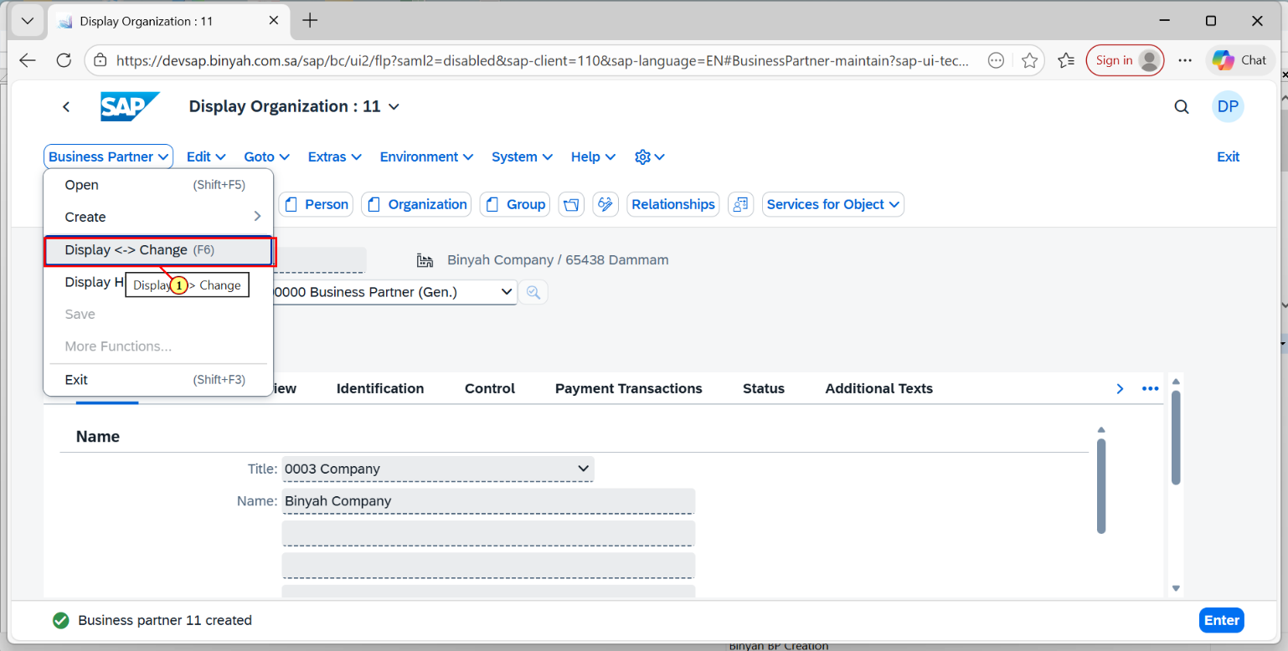

| Step | Action |
| --- | --- |
| (1) | Click on "Display <-> Change". |

Change Organization: 11 - Personal - Microsoft​ Edge

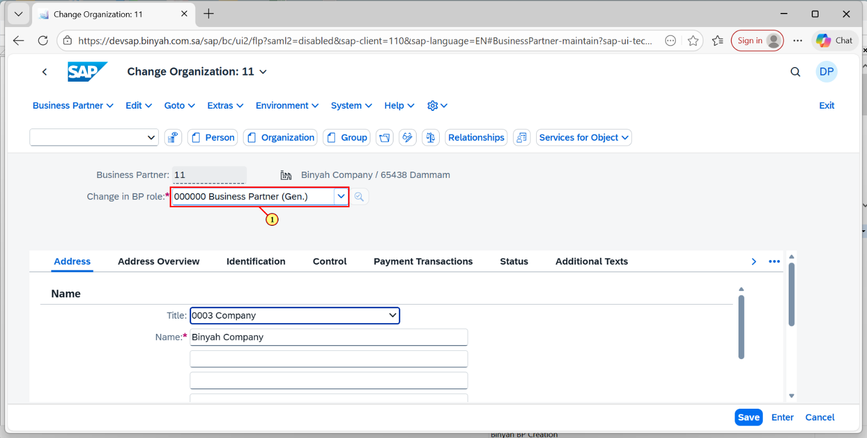

| Step | Action |
| --- | --- |
| (1) | Now in "Change in BP role field".Click on Dropdown menu. |

Change Organization: 11 - Personal - Microsoft​ Edge

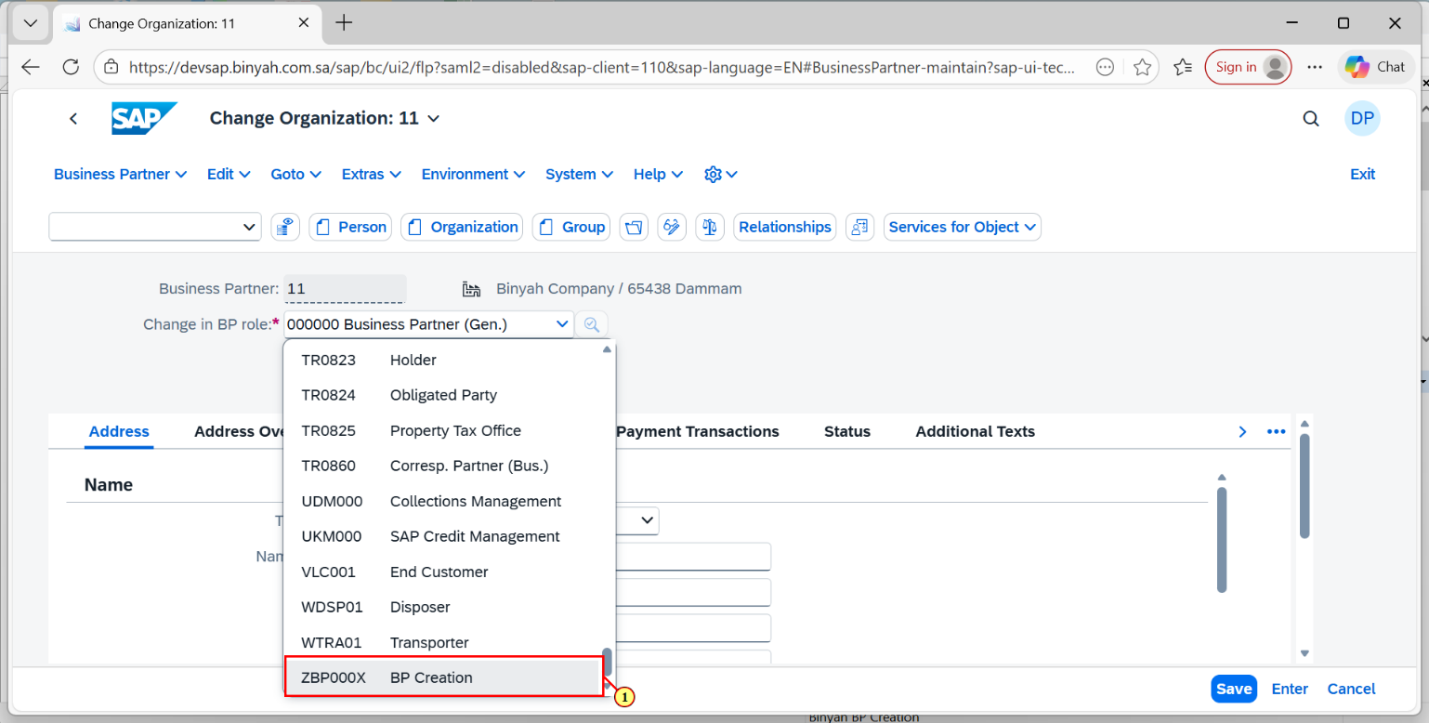

| Step | Action |
| --- | --- |
| (1) | Now Select ZBP000X option and Click "Enter". |

Change Organization: 11, new role BP Creation - Personal - Microsoft​ Edge

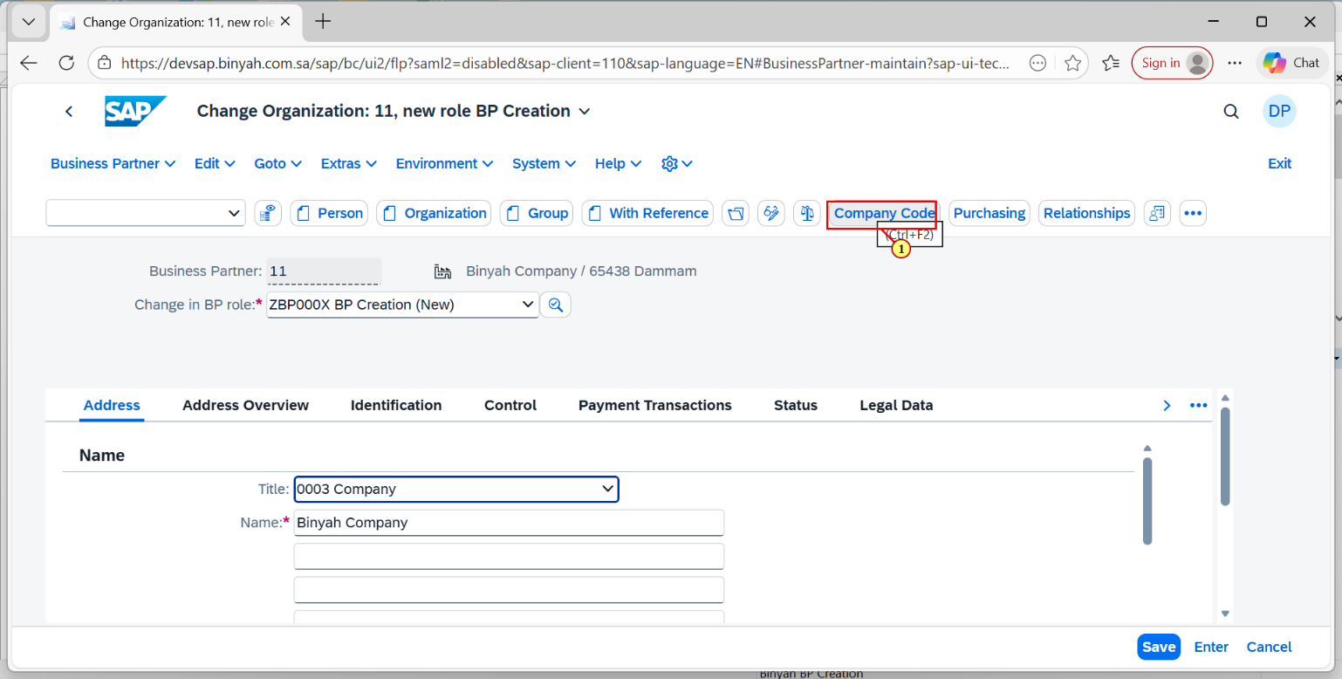

| Step | Action |
| --- | --- |
| (1) | Click on "Company Code". |

Change Organization: 11, new role BP Creation - Personal - Microsoft​ Edge

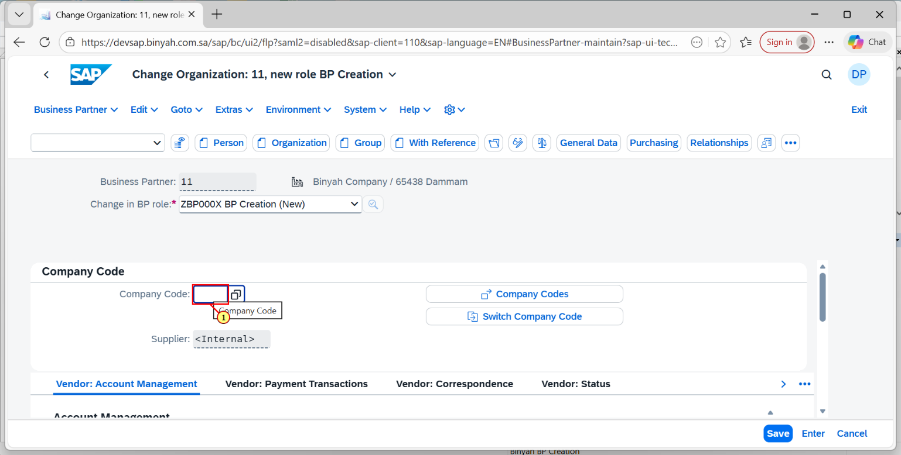

| Step | Action |
| --- | --- |
| (1) | Click On Company Code Search help. |

Change Organization: 11, new role BP Creation - Personal - Microsoft​ Edge

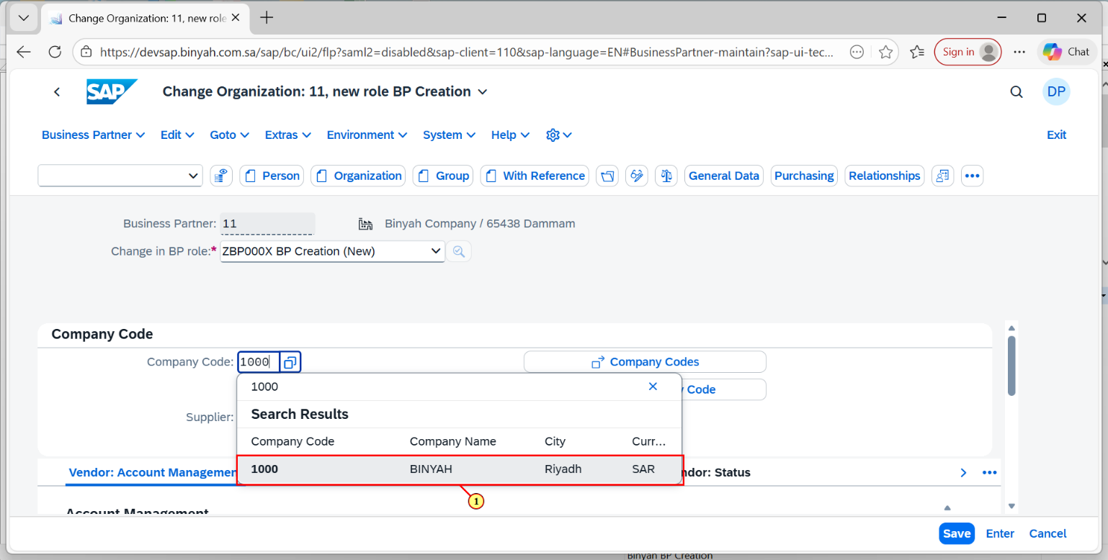

| Step | Action |
| --- | --- |
| (1) | Select the Plant and Press "Enter". |

Change Organization: 11, new role BP Creation - Personal - Microsoft​ Edge

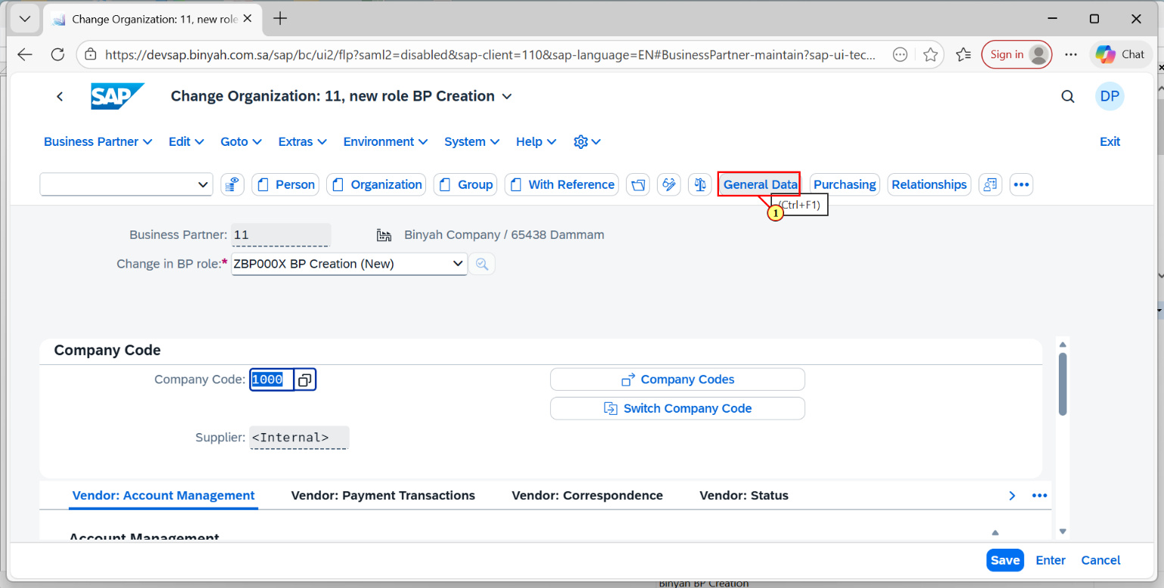

| Step | Action |
| --- | --- |
| (1) | Click on General Data. |

Change Organization: 11, new role BP Creation - Personal - Microsoft​ Edge

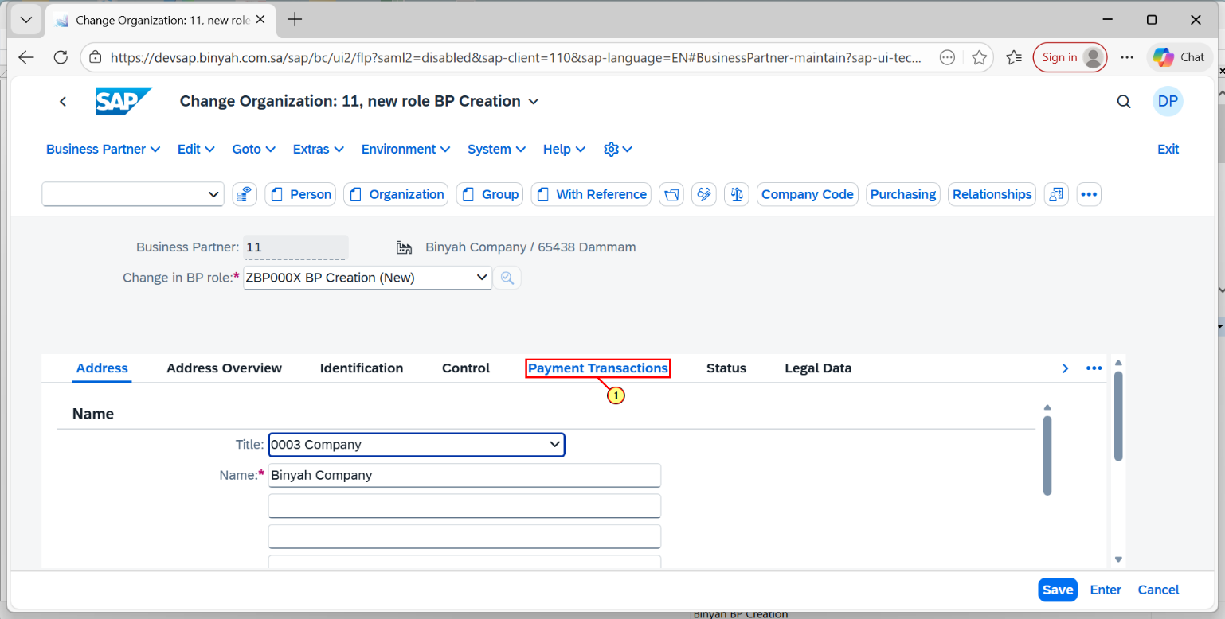

| Step | Action |
| --- | --- |
| (1) | Click On Payament Transaction Tab. |

Change Organization: 11, new role BP Creation - Personal - Microsoft​ Edge

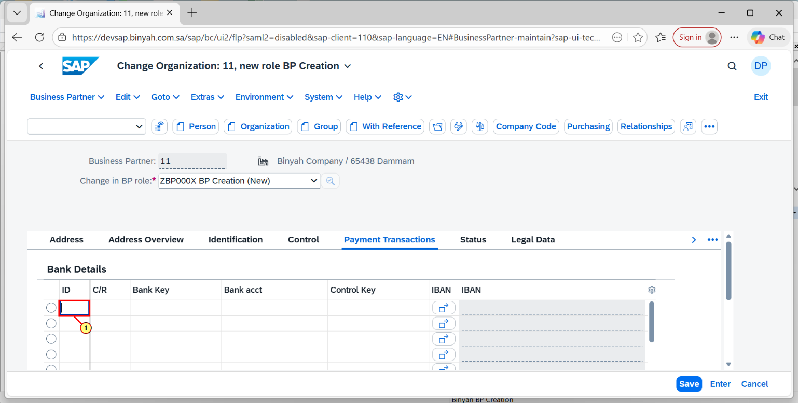

| Step | Action |
| --- | --- |
| (1) | Click On ID field and enter the BP's Bank ID. |

Change Organization: 11, new role BP Creation - Personal - Microsoft​ Edge

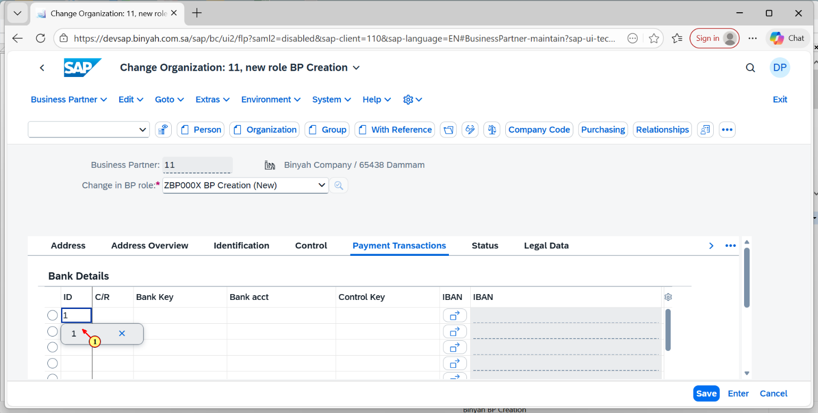

| Step | Action |
| --- | --- |
| (1) | Entering the ID in the field click "Enter". |

Change Organization: 11, new role BP Creation - Personal - Microsoft​ Edge

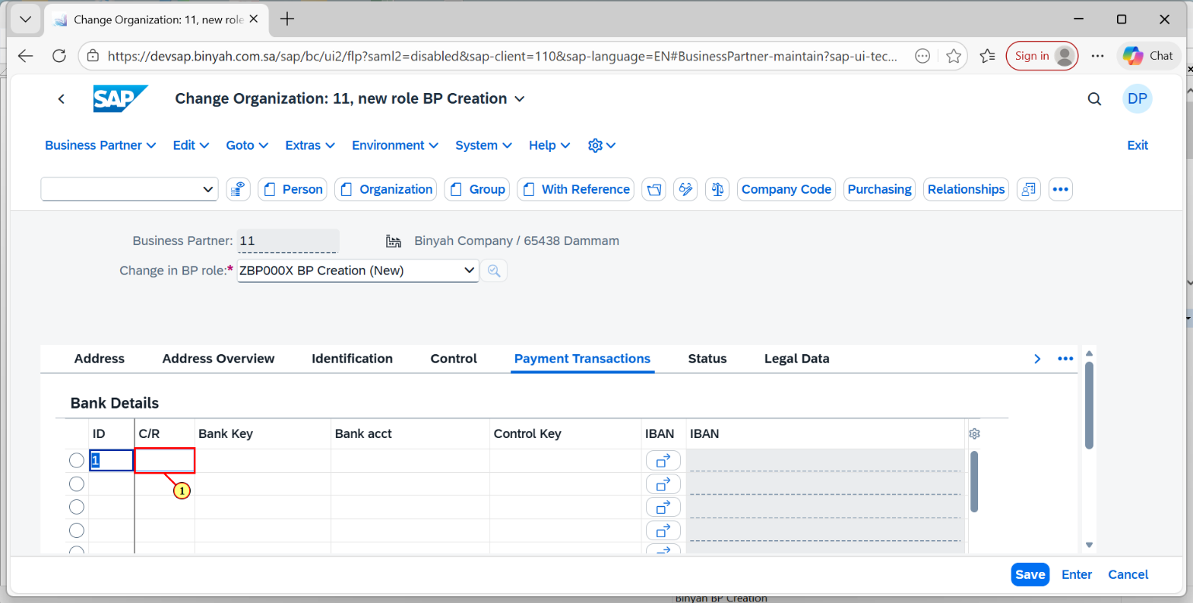

| Step | Action |
| --- | --- |
| (1) | Click on C/R field. |

Change Organization: 11, new role BP Creation - Personal - Microsoft​ Edge

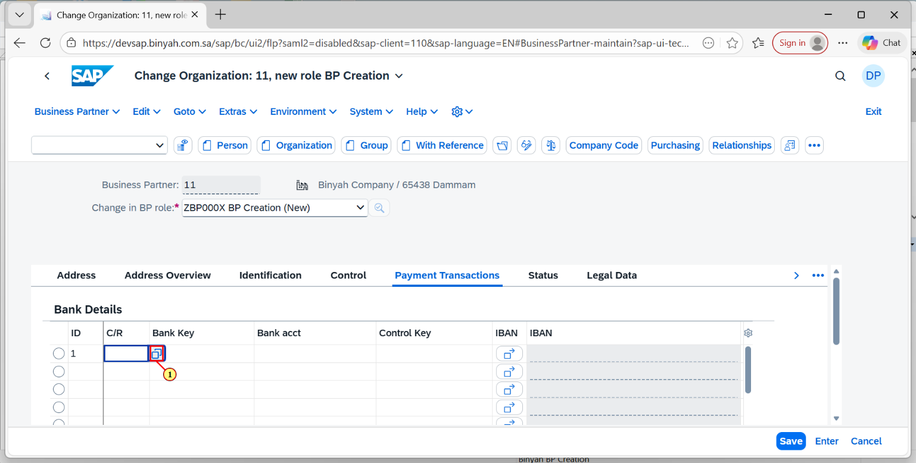

| Step | Action |
| --- | --- |
| (1) | Click on Country/Region search help. |

Change Organization: 11, new role BP Creation - Personal - Microsoft​ Edge

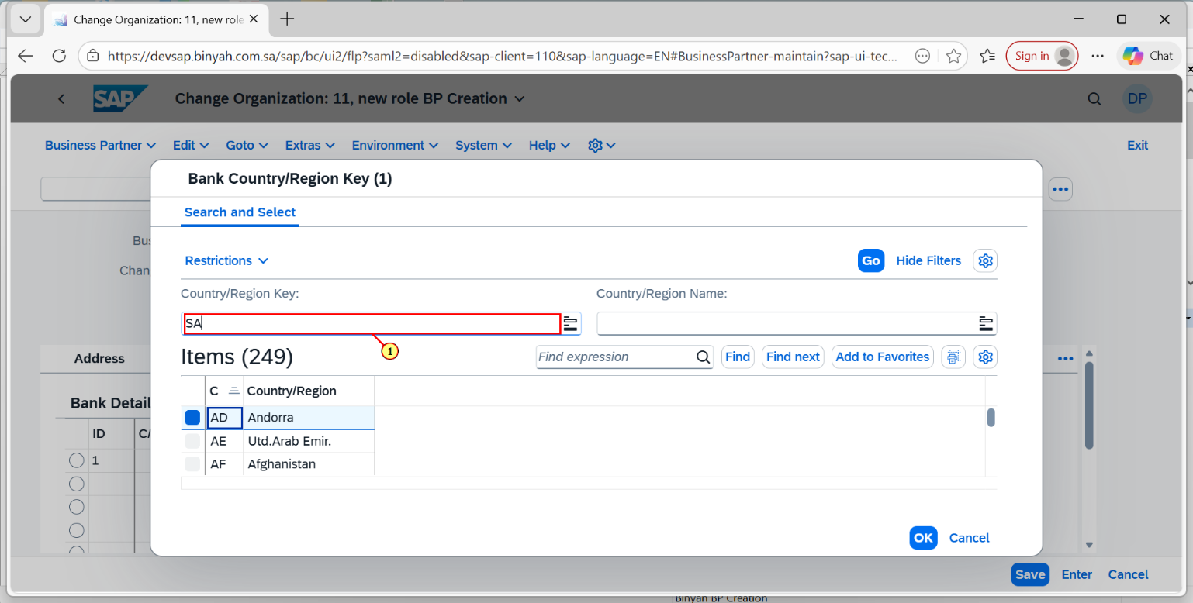

| Step | Action |
| --- | --- |
| (1) | Enter the search term of the country. |

Change Organization: 11, new role BP Creation - Personal - Microsoft​ Edge

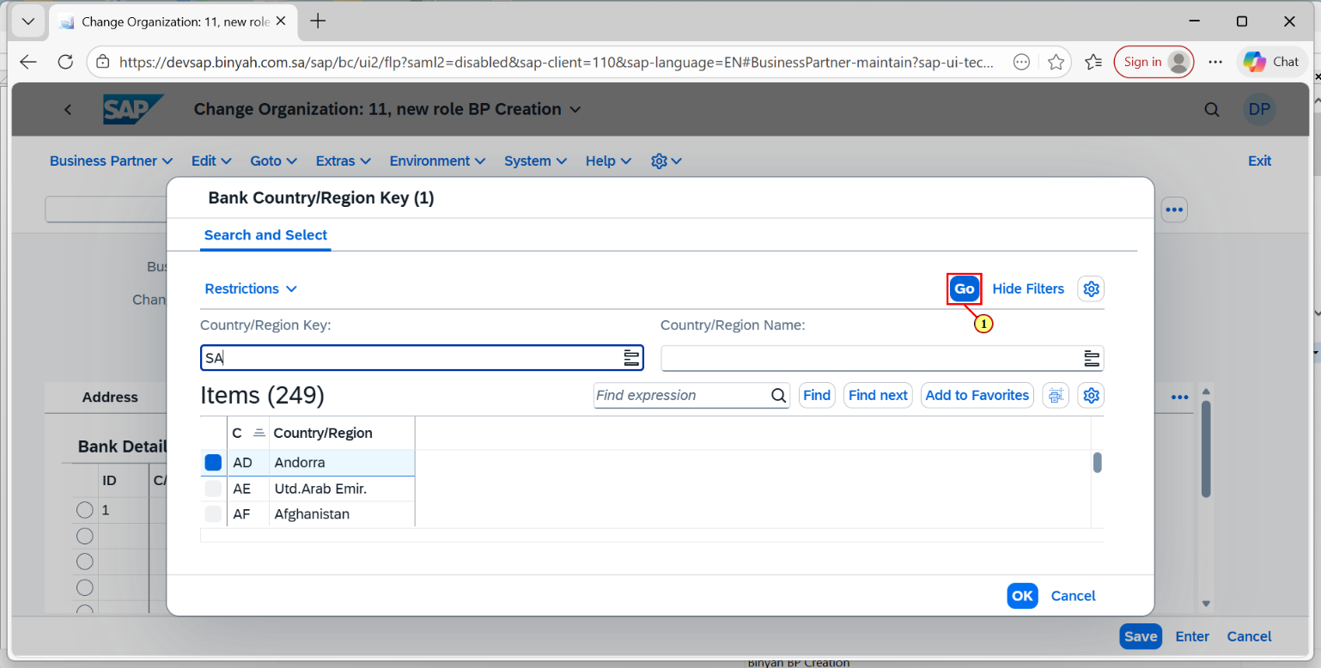

| Step | Action |
| --- | --- |
| (1) | Now press "GO" button. |

Change Organization: 11, new role BP Creation - Personal - Microsoft​ Edge

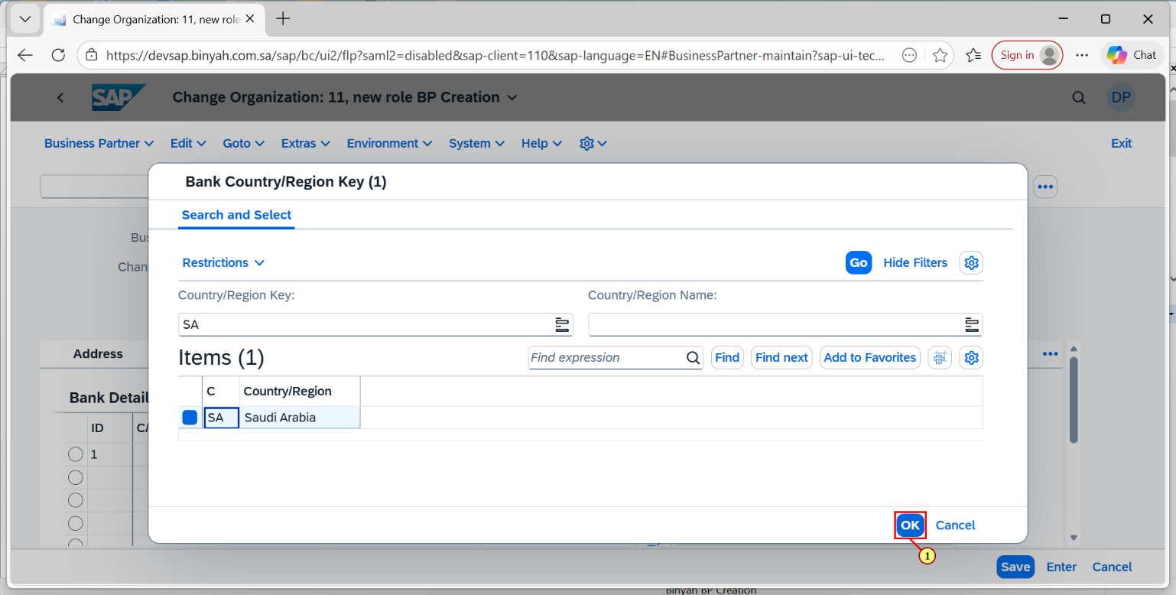

| Step | Action |
| --- | --- |
| (1) | Click on "OK". |

Change Organization: 11, new role BP Creation - Personal - Microsoft​ Edge

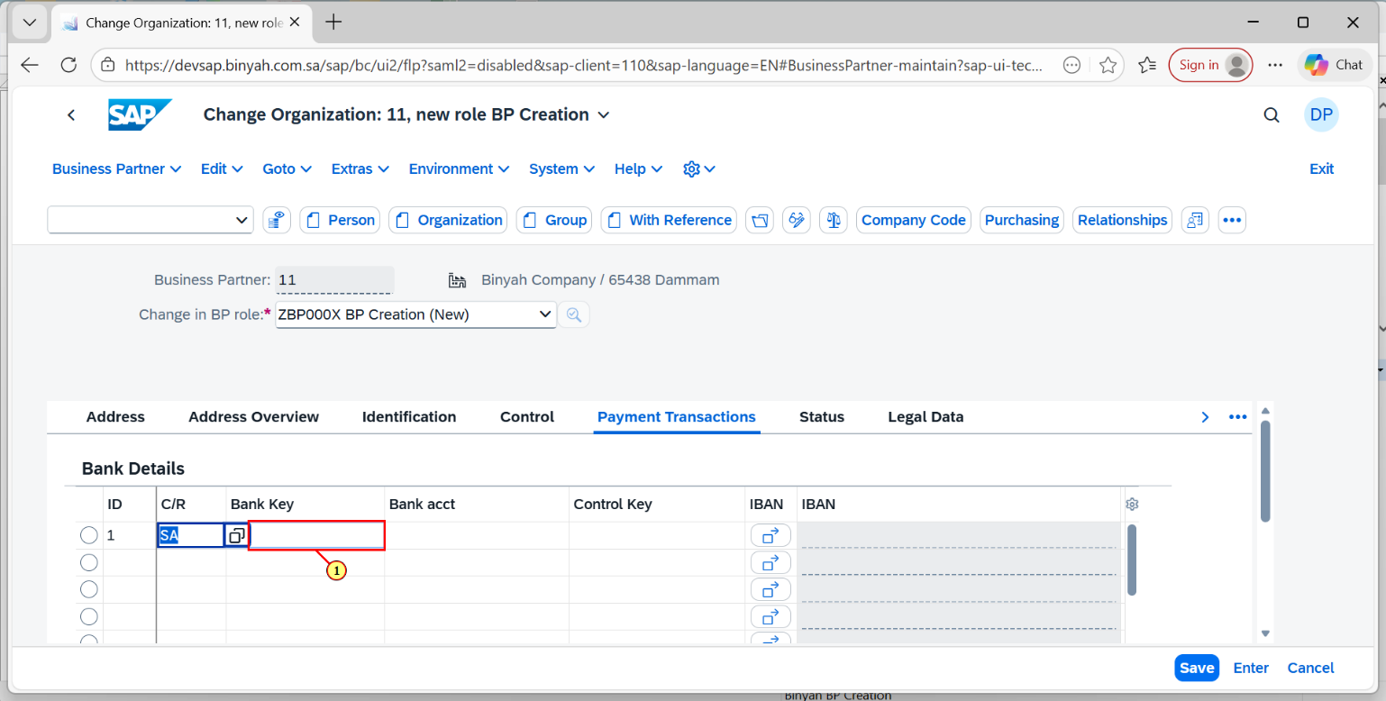

| Step | Action |
| --- | --- |
| (1) | Bank key Tab, Click on search help. |

Change Organization: 11, new role BP Creation - Personal - Microsoft​ Edge

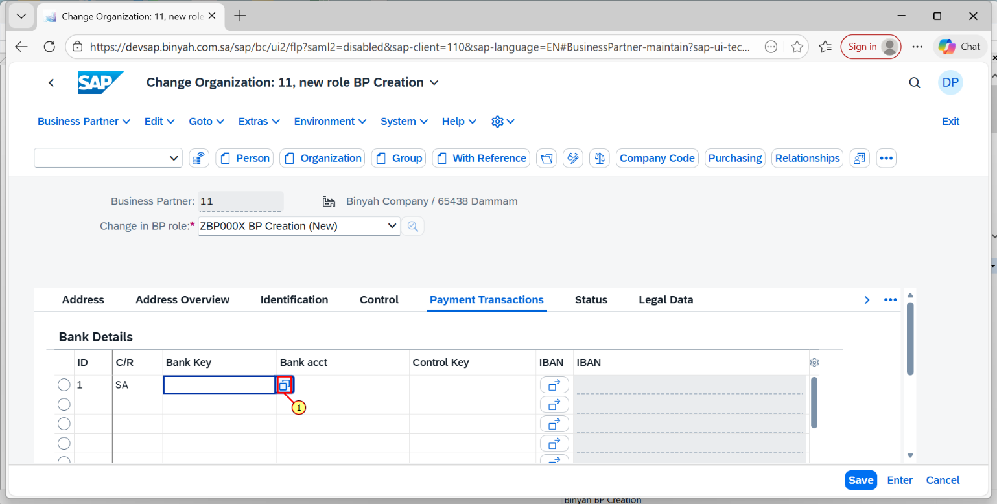

| Step | Action |
| --- | --- |
| (1) | Click on search help icon. |

Change Organization: 11, new role BP Creation - Personal - Microsoft​ Edge

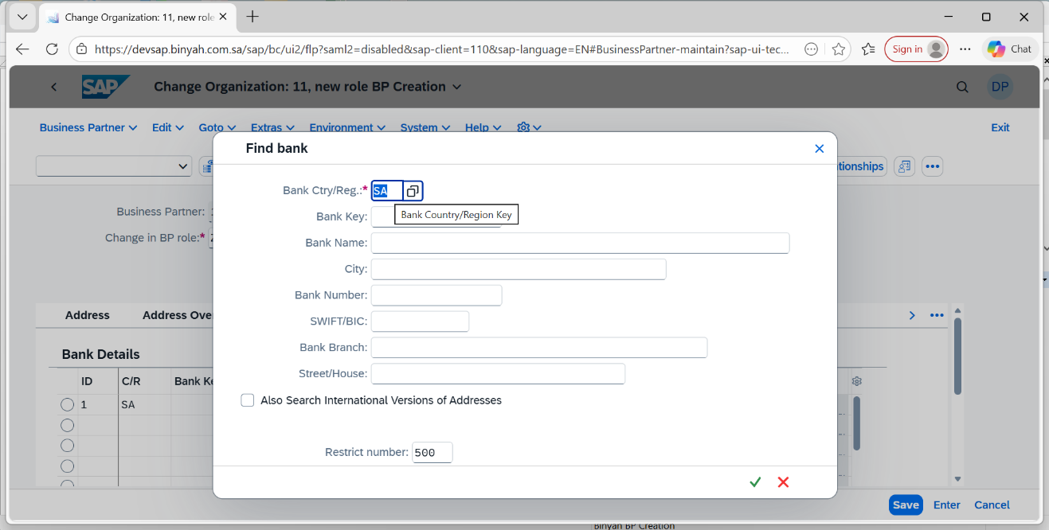

| Step | Action |
| --- | --- |
|  | Enter the Bank ctry/Reg and press "Enter". |

Change Organization: 11, new role BP Creation - Personal - Microsoft​ Edge

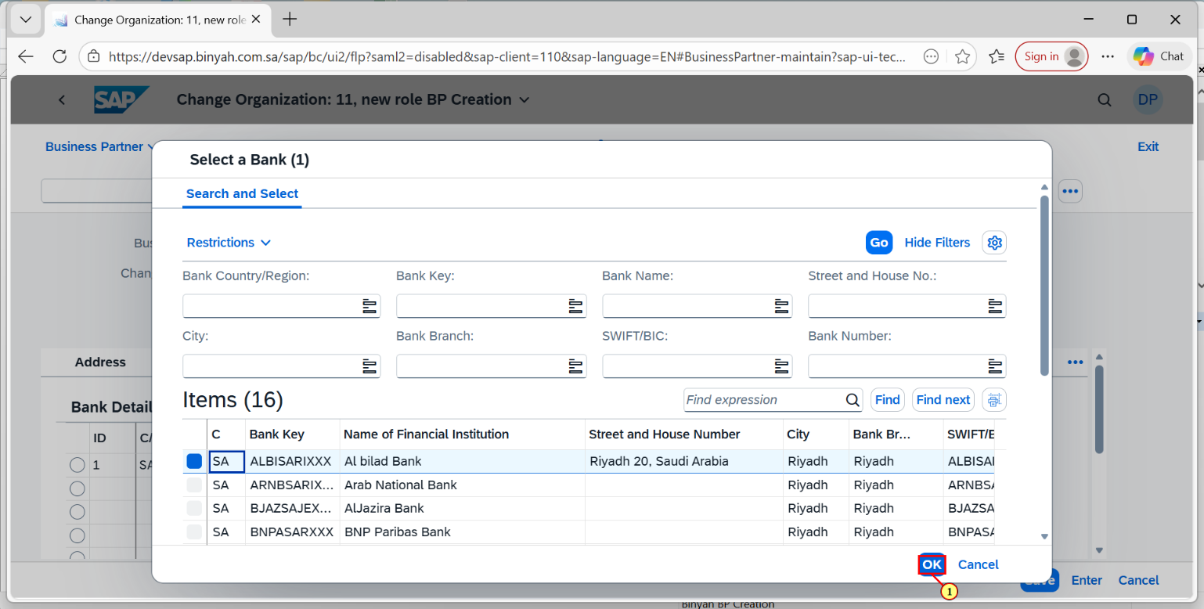

| Step | Action |
| --- | --- |
| (1) | Click on "OK". |

Change Organization: 11, new role BP Creation - Personal - Microsoft​ Edge

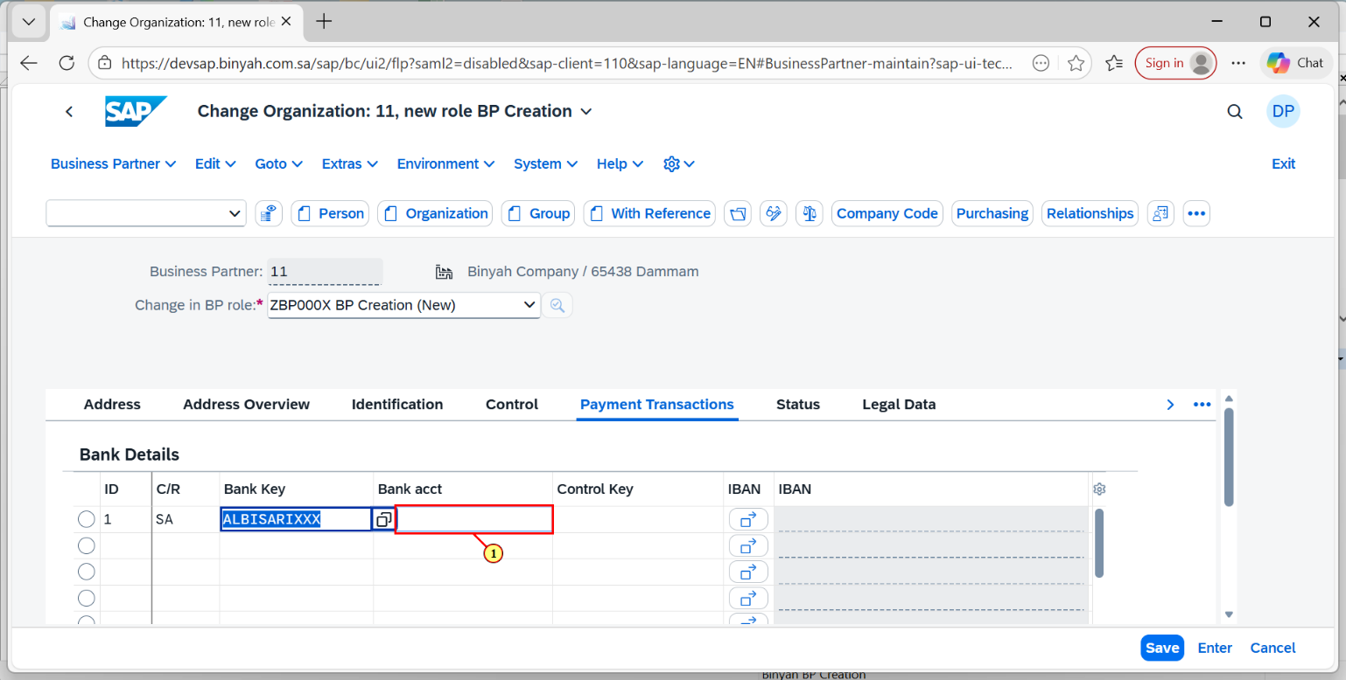

| Step | Action |
| --- | --- |
| (1) | Enter the Bank Account Number. |

Change Organization: 11, new role BP Creation - Personal - Microsoft​ Edge

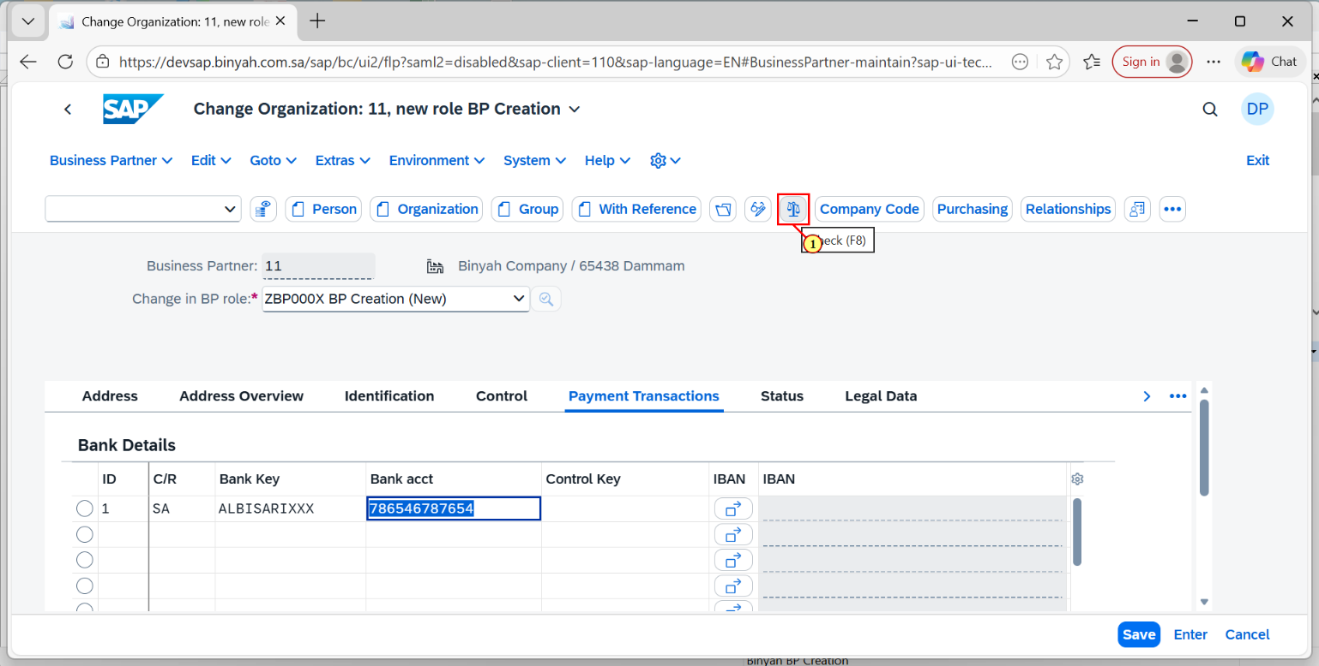

| Step | Action |
| --- | --- |
| (1) | Click on "CHECK" to check errors. |

Change Organization: 11, new role BP Creation - Personal - Microsoft​ Edge

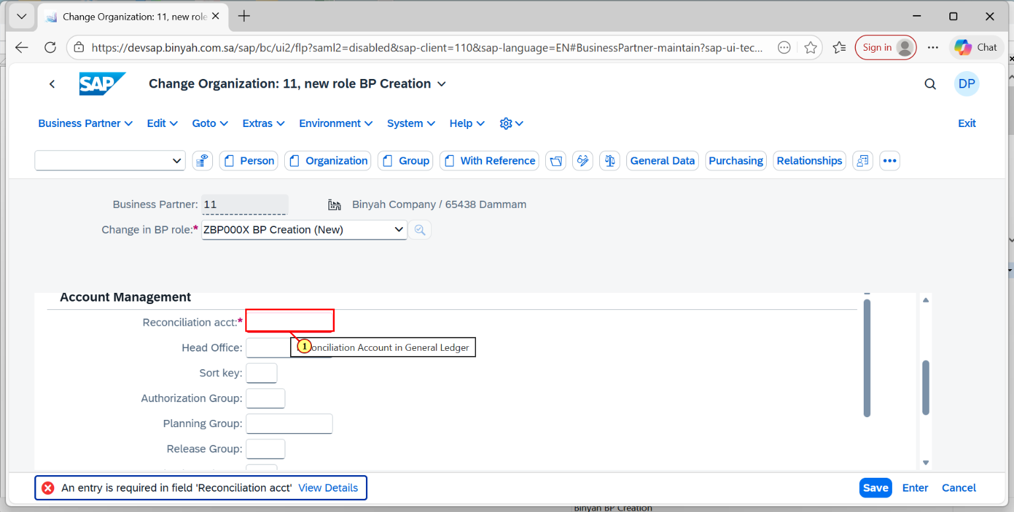

| Step | Action |
| --- | --- |
| (1) | Click "company code" Account Management Tab and Enter the Reconcilation account. |

Change Organization: 11, new role BP Creation - Personal - Microsoft​ Edge

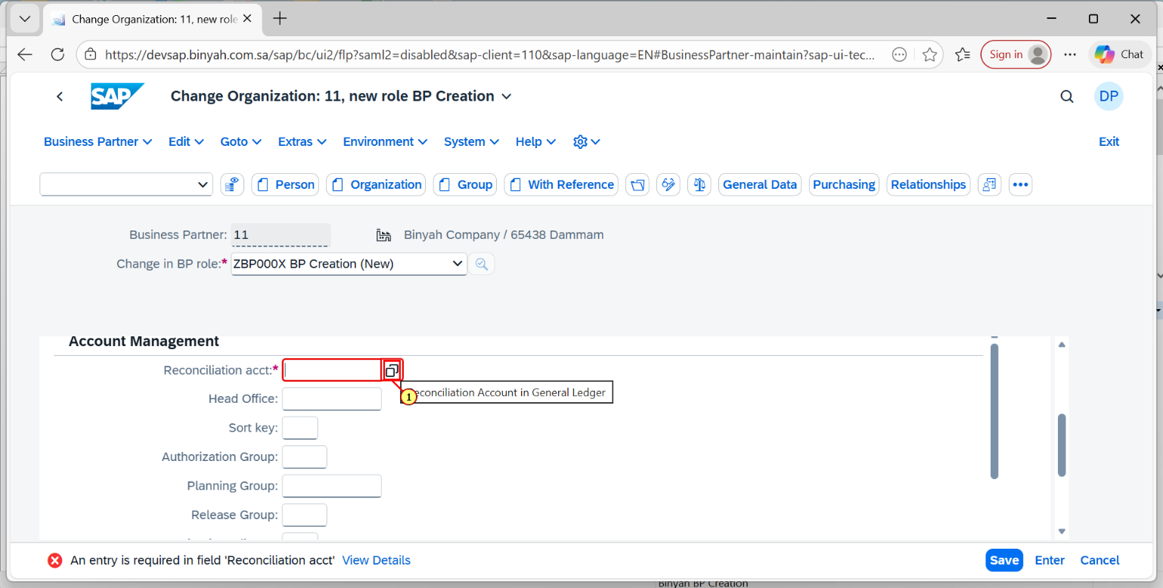

| Step | Action |
| --- | --- |
| (1) | Click on Search term and press " Enter". |

Change Organization: 11, new role BP Creation - Personal - Microsoft​ Edge

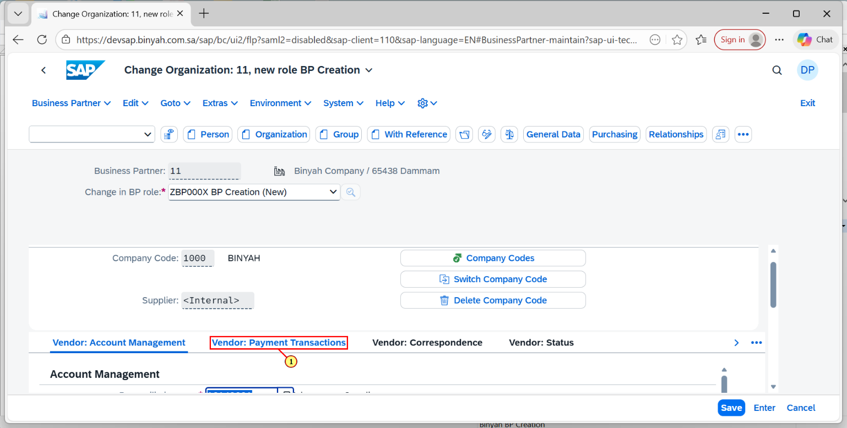

| Step | Action |
| --- | --- |
| (1) | Click on Vendor:Payment Transaction tab. |

Change Organization: 11, new role BP Creation - Personal - Microsoft​ Edge

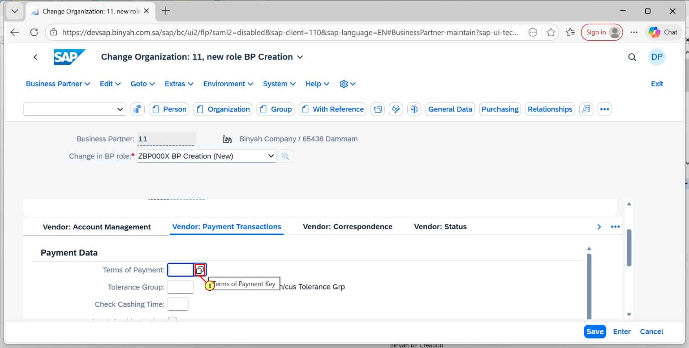

| Step | Action |
| --- | --- |
| (1) | Click on Search help icon. |

Change Organization: 11, new role BP Creation - Personal - Microsoft​ Edge

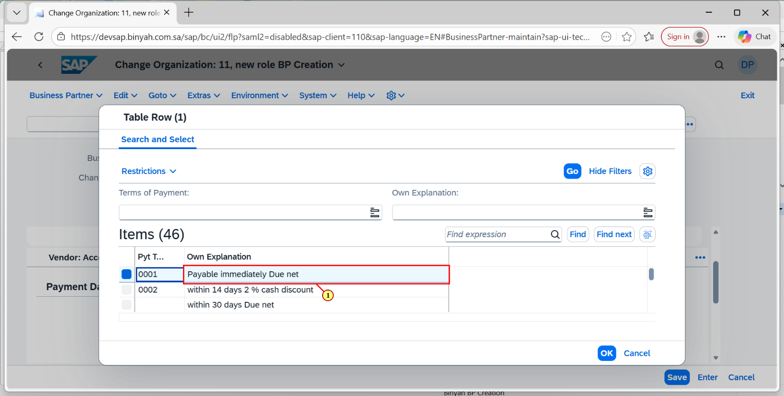

| Step | Action |
| --- | --- |
| (1) | Choose the payment terms. |

Change Organization: 11, new role BP Creation - Personal - Microsoft​ Edge

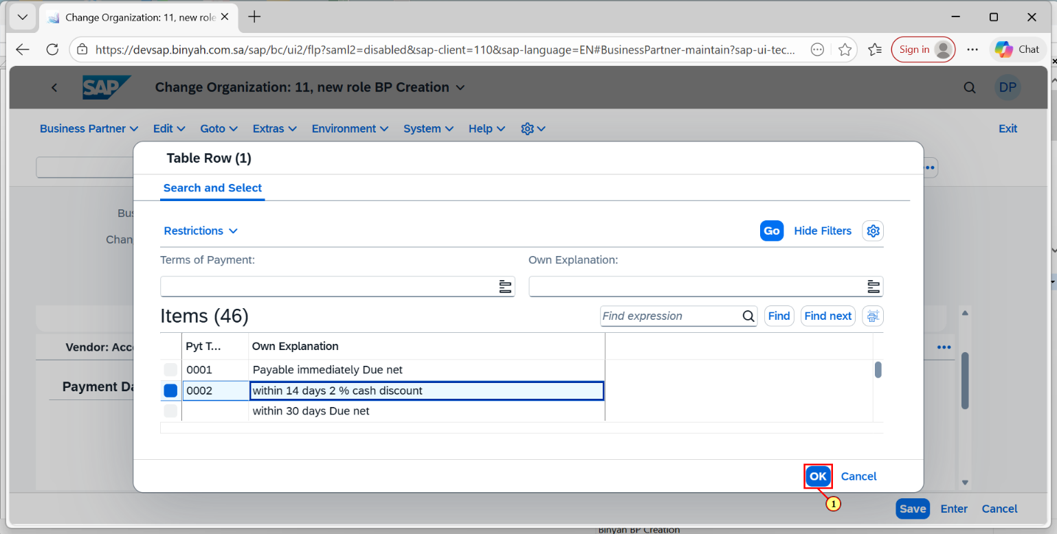

| Step | Action |
| --- | --- |
| (1) | Click on "OK". |

Change Organization: 11, new role BP Creation - Personal - Microsoft​ Edge

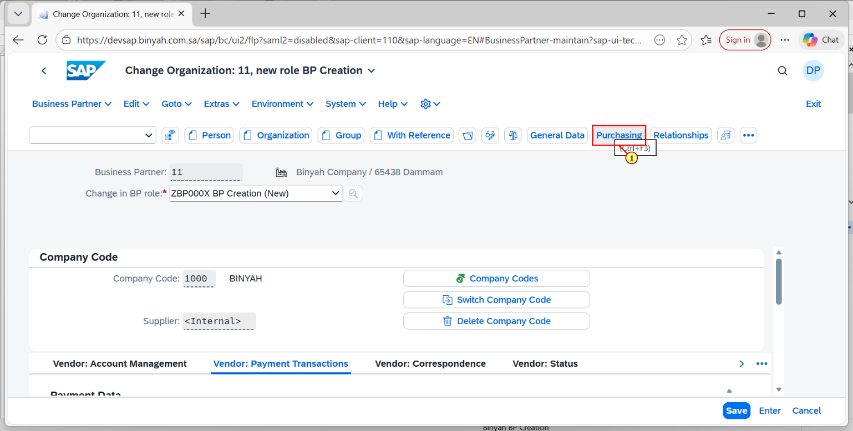

| Step | Action |
| --- | --- |
| (1) | Click on "Purchasing". |

Change Organization: 11, new role BP Creation - Personal - Microsoft​ Edge

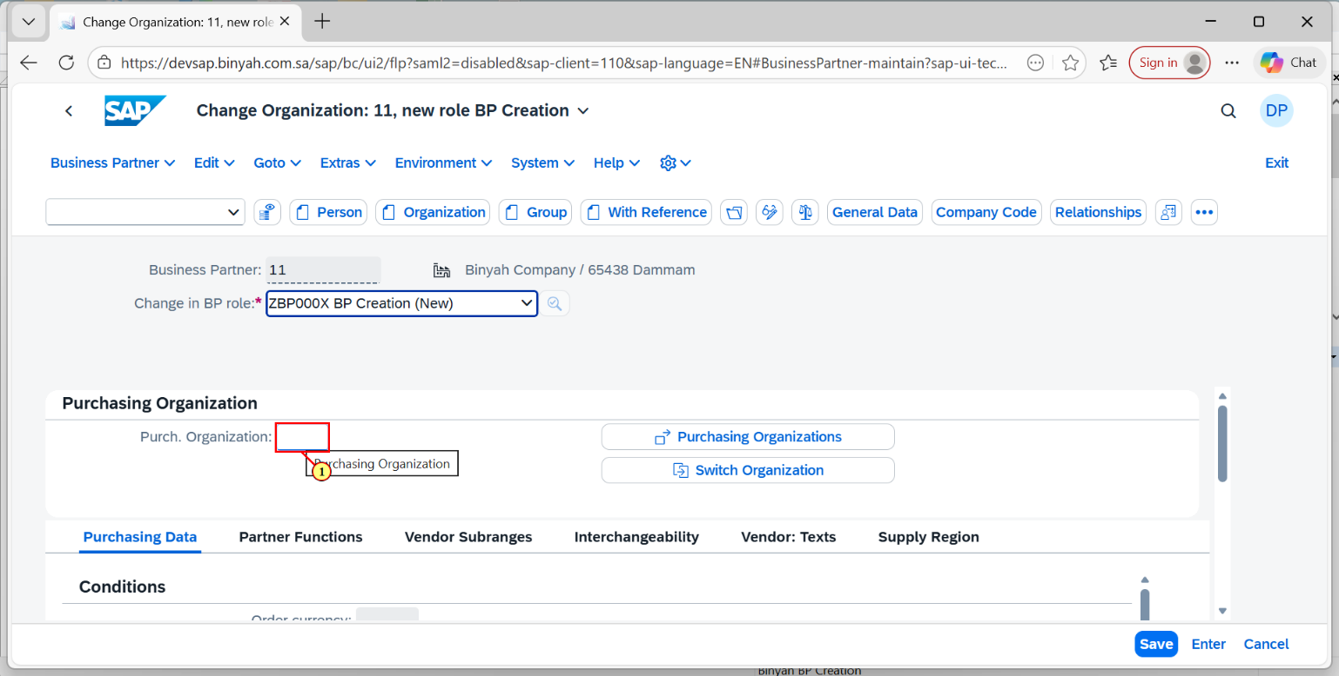

| Step | Action |
| --- | --- |
| (1) | Click on the Purchase Organization Search help. |

Change Organization: 11, new role BP Creation - Personal - Microsoft​ Edge

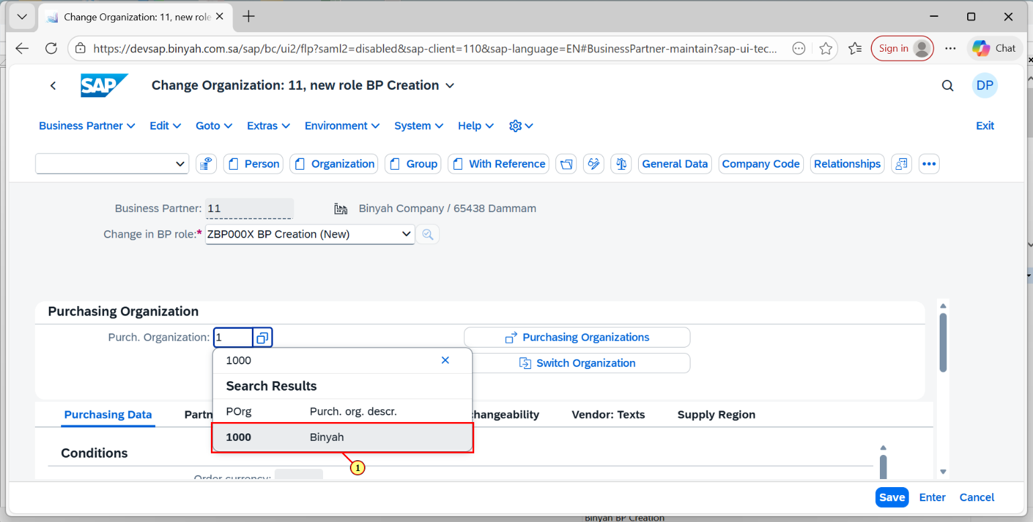

| Step | Action |
| --- | --- |
| (1) | Select the purchase organization and click "Enter". |

Change Organization: 11, new role BP Creation - Personal - Microsoft​ Edge

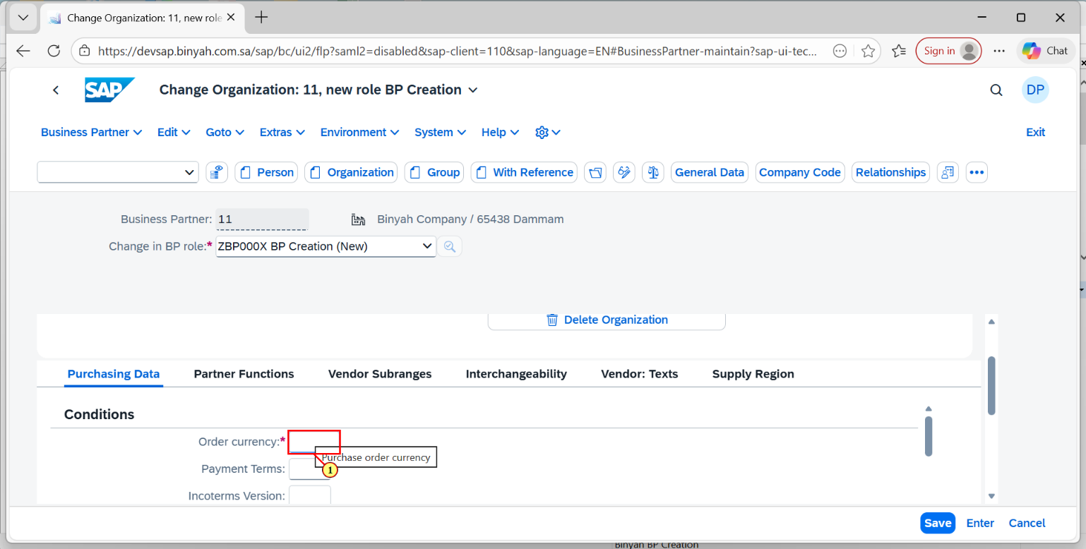

| Step | Action |
| --- | --- |
| (1) | Enter the order currency. |

Change Organization: 11, new role BP Creation - Personal - Microsoft​ Edge

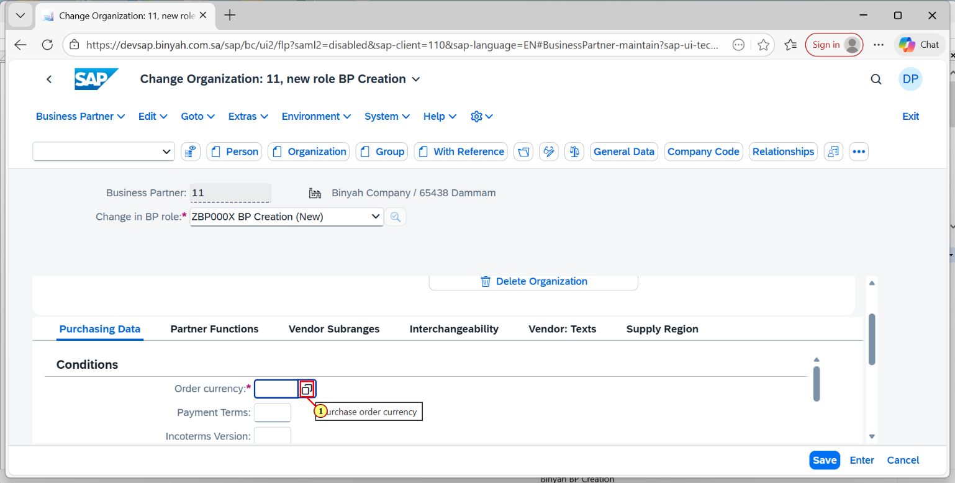

| Step | Action |
| --- | --- |
| (1) | Click on Order Currency Search help. |

Change Organization: 11, new role BP Creation - Personal - Microsoft​ Edge

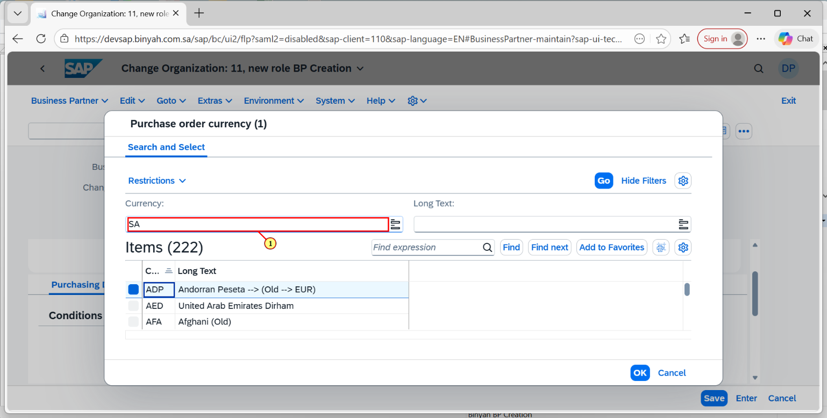

| Step | Action |
| --- | --- |
| (1) | Enter the search help terms. |

Change Organization: 11, new role BP Creation - Personal - Microsoft​ Edge

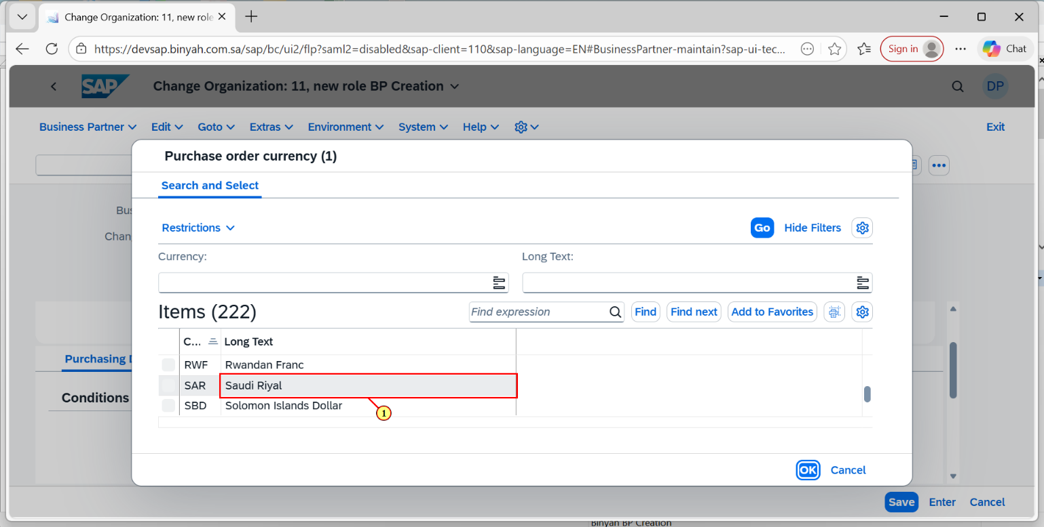

| Step | Action |
| --- | --- |
| (1) | Select the Currency and click on "OK". |

Change Organization: 11, new role BP Creation - Personal - Microsoft​ Edge

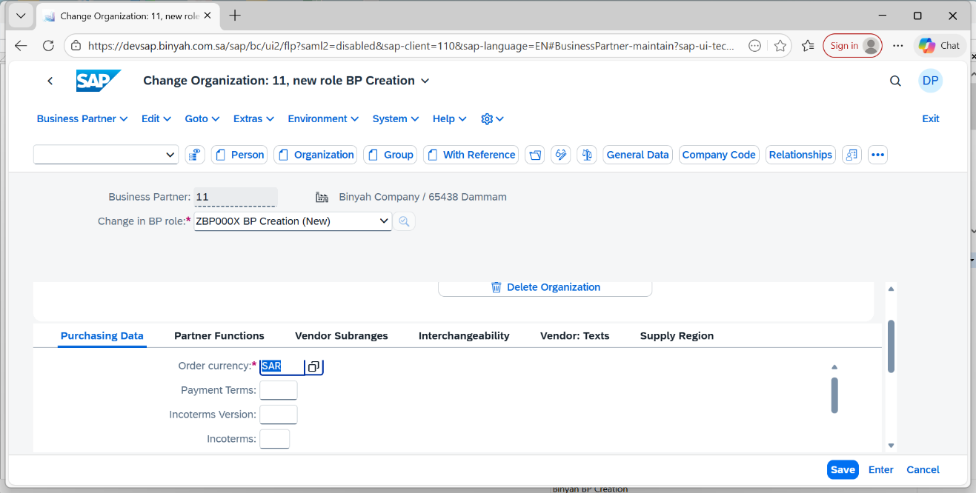

| Step | Action |
| --- | --- |
|  | Now press "Enter". |

Change Organization: 11, new role BP Creation - Personal - Microsoft​ Edge

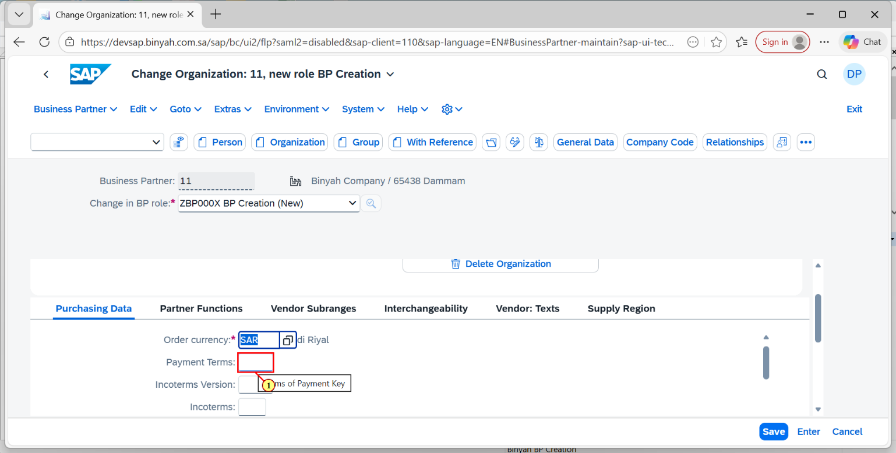

| Step | Action |
| --- | --- |
| (1) | Click on Payment terms Field to enter the term. |

Change Organization: 11, new role BP Creation - Personal - Microsoft​ Edge

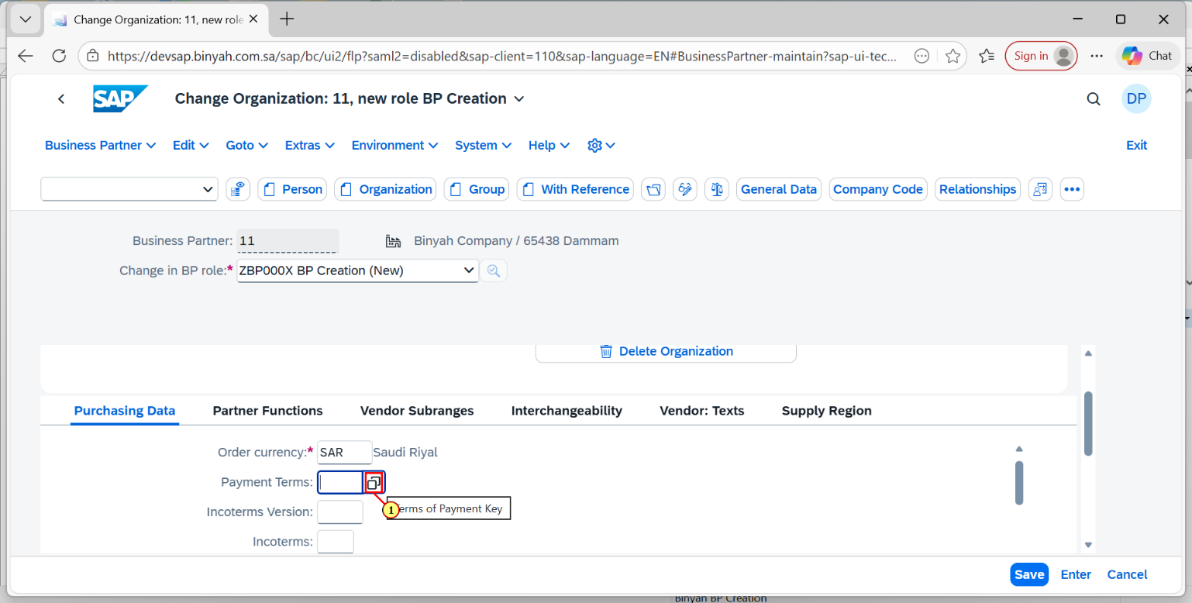

| Step | Action |
| --- | --- |
| (1) | Click on Search help of Payment Terms. |

Change Organization: 11, new role BP Creation - Personal - Microsoft​ Edge

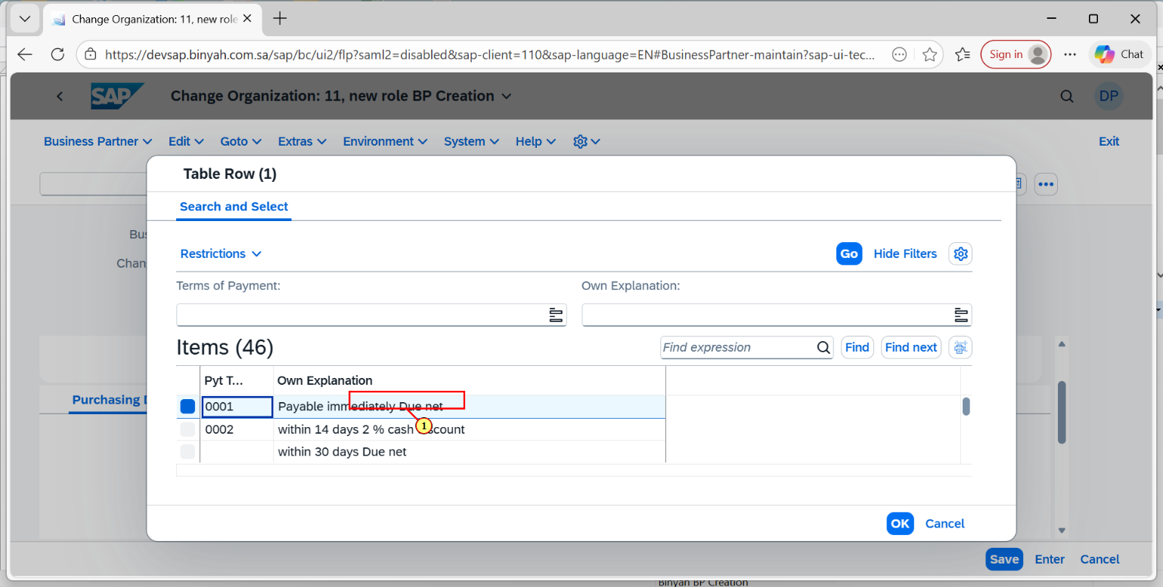

| Step | Action |
| --- | --- |
| (1) | Select the paymen Term. |

Change Organization: 11, new role BP Creation - Personal - Microsoft​ Edge

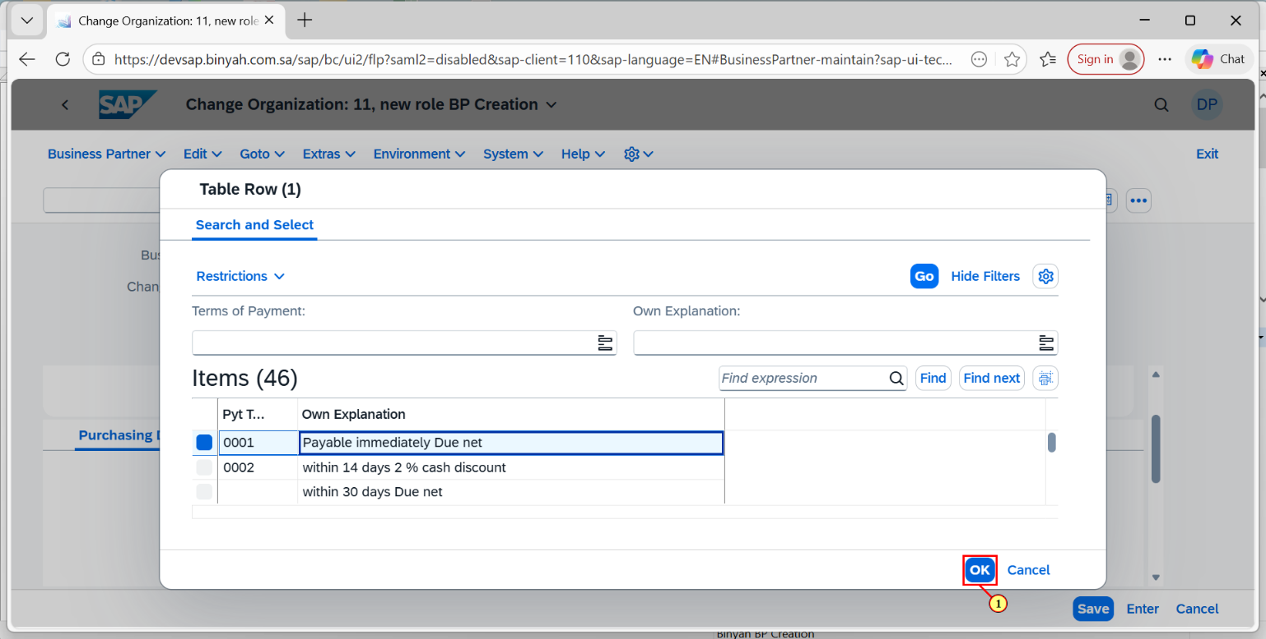

| Step | Action |
| --- | --- |
| (1) | Now click on "OK". |

Change Organization: 11, new role BP Creation - Personal - Microsoft​ Edge

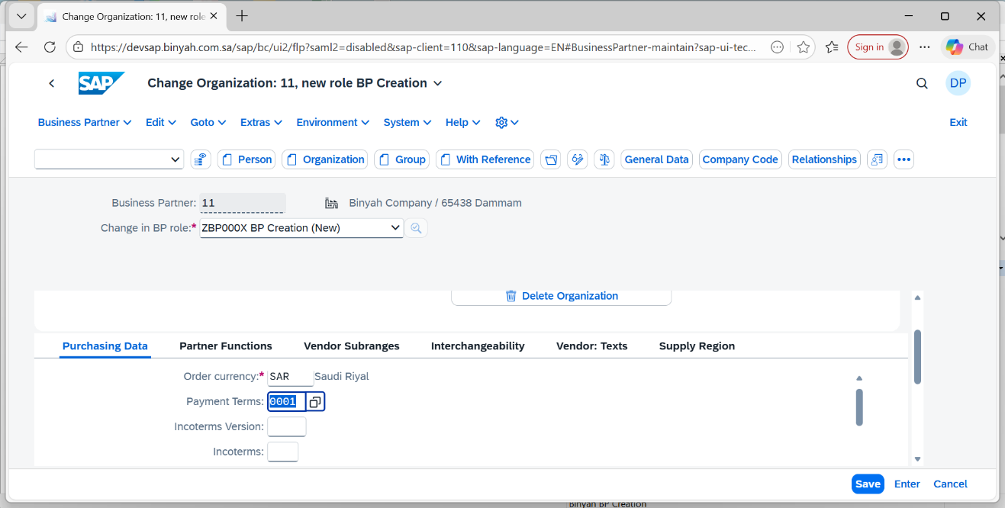

| Step | Action |
| --- | --- |
|  | Now press "Enter**".** |

Change Organization: 11, new role BP Creation - Personal - Microsoft​ Edge

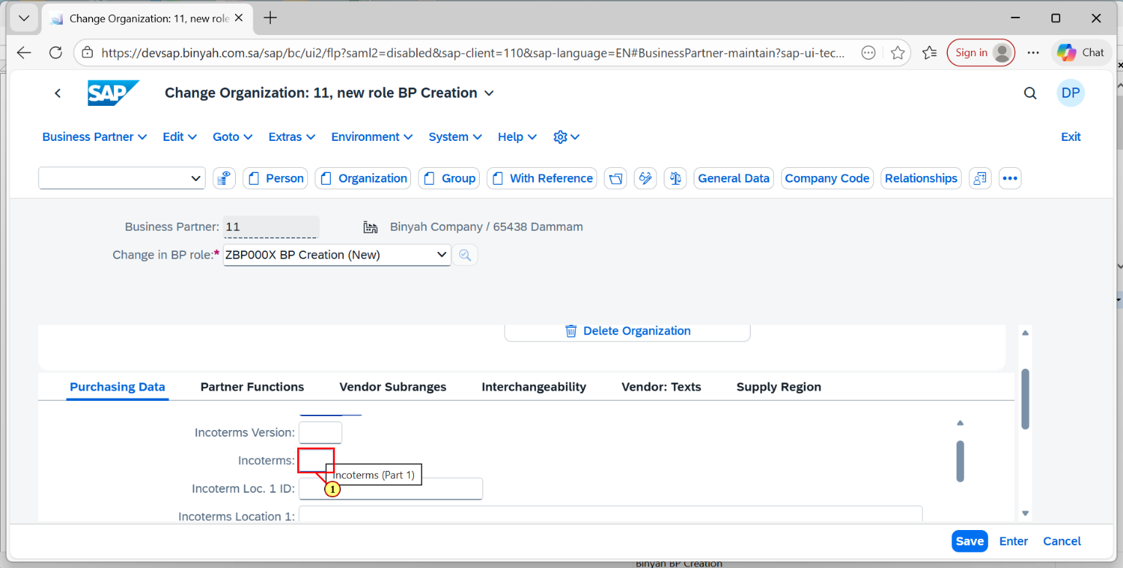

| Step | Action |
| --- | --- |
| (1) | Enter the Incoterms. |

Change Organization: 11, new role BP Creation - Personal - Microsoft​ Edge

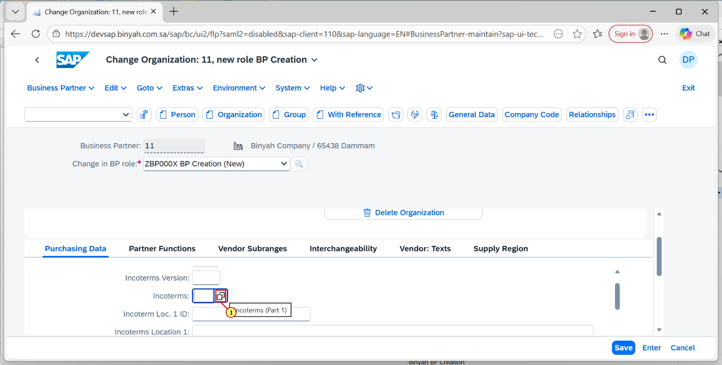

| Step | Action |
| --- | --- |
| (1) | Click on Search help icon of Incoterms. |

Change Organization: 11, new role BP Creation - Personal - Microsoft​ Edge

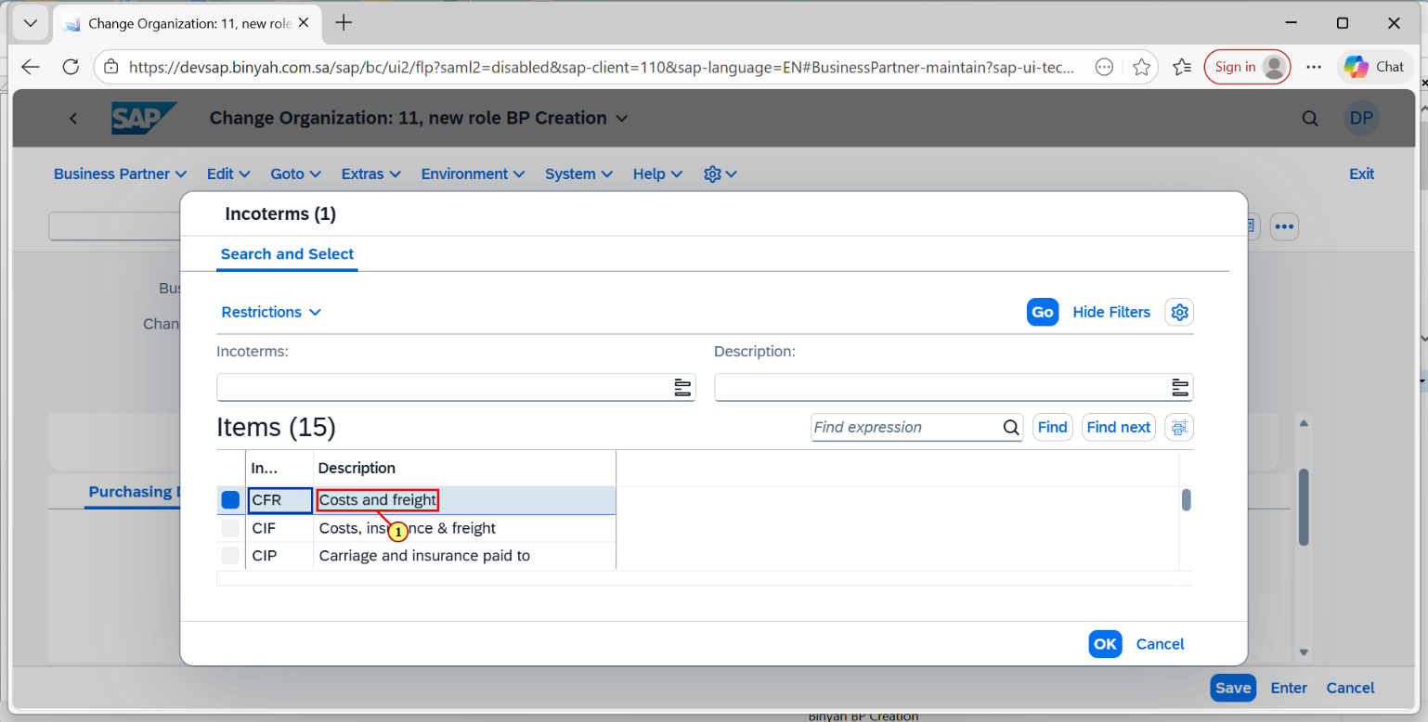

| Step | Action |
| --- | --- |
| (1) | Now click the Item that we require from the list of items. |

Change Organization: 11, new role BP Creation - Personal - Microsoft​ Edge

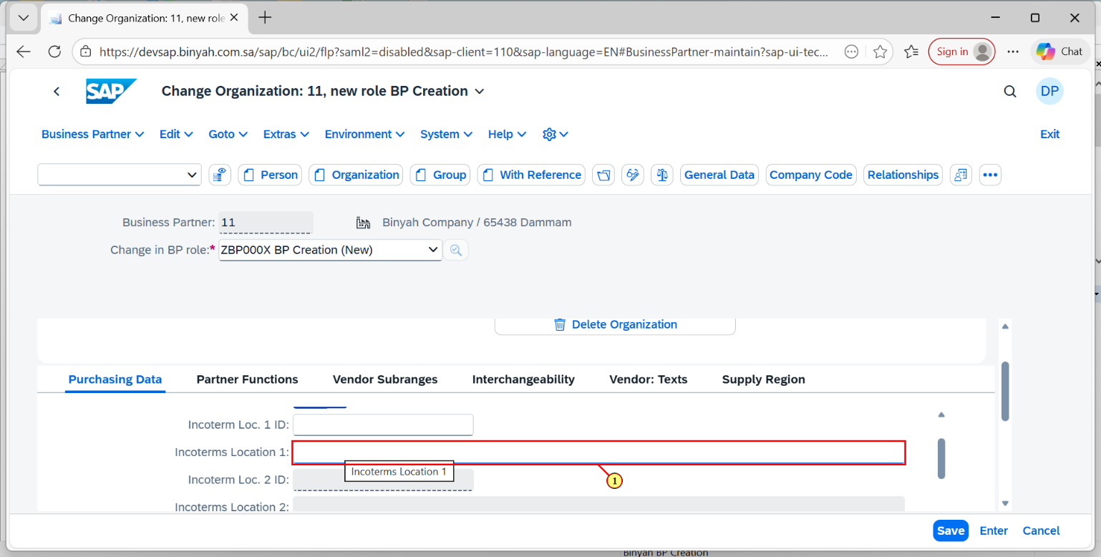

| Step | Action |
| --- | --- |
| (1) | Enter the Incoterm location 1. |

Change Organization: 11, new role BP Creation - Personal - Microsoft​ Edge

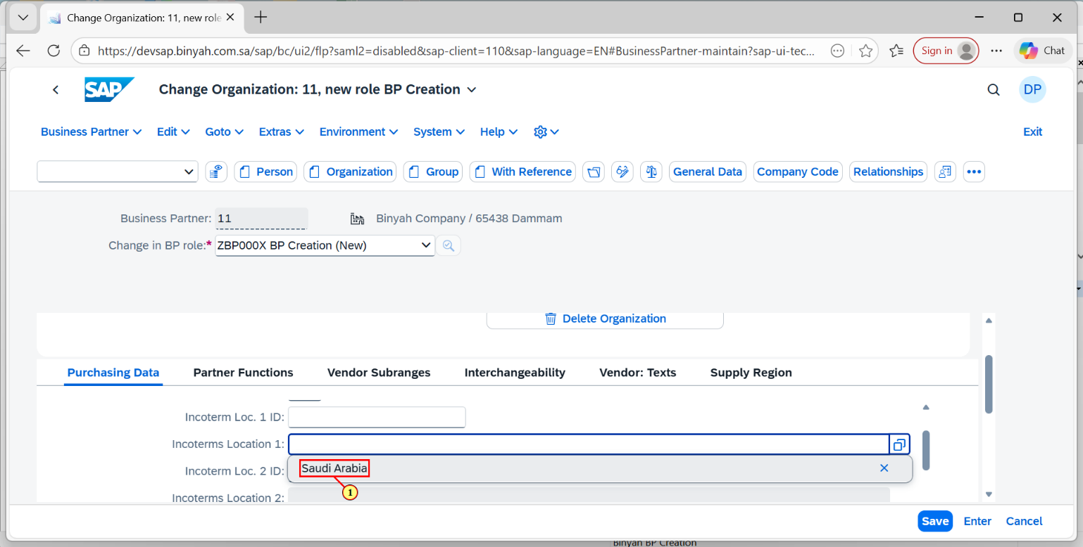

| Step | Action |
| --- | --- |
| (1) | Then click "Enter". |

Change Organization: 11, new role BP Creation - Personal - Microsoft​ Edge

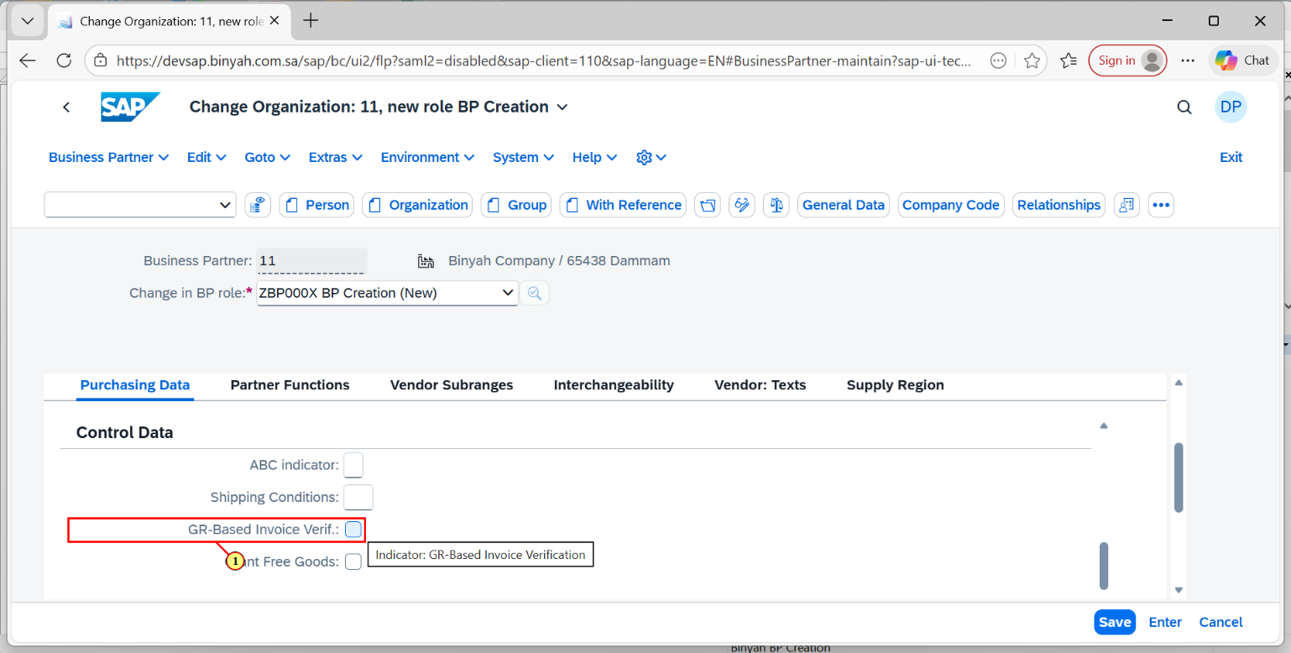

| Step | Action |
| --- | --- |
| (1) | Click for GR-Based Invoice Verification "CheckBox". |

Change Organization: 11, new role BP Creation - Personal - Microsoft​ Edge

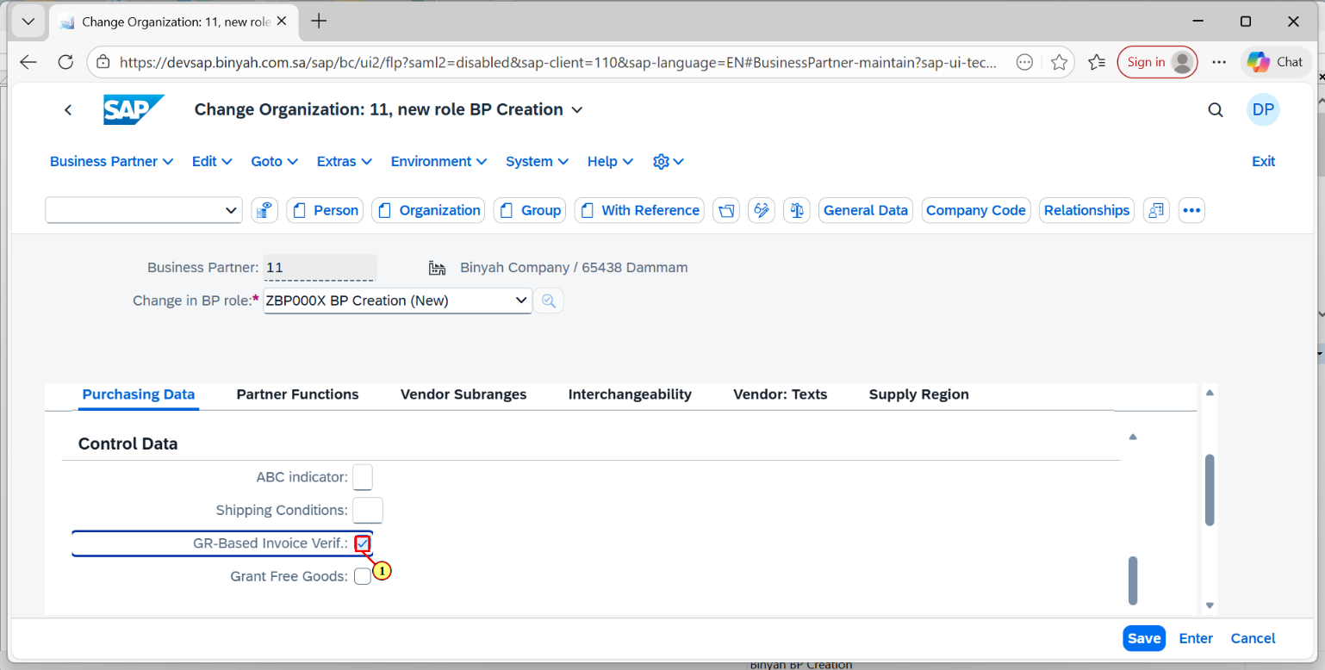

| Step | Action |
| --- | --- |
| (1) | Make the Checkbox "Ticked". |

Change Organization: 11, new role BP Creation - Personal - Microsoft​ Edge

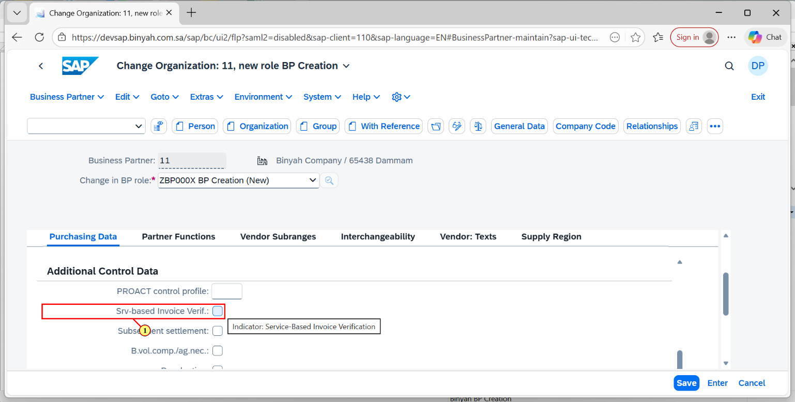

| Step | Action |
| --- | --- |
| (1) | Make the Srv-based Invoice Verification checkbox "Ticked". |

Change Organization: 11, new role BP Creation - Personal - Microsoft​ Edge

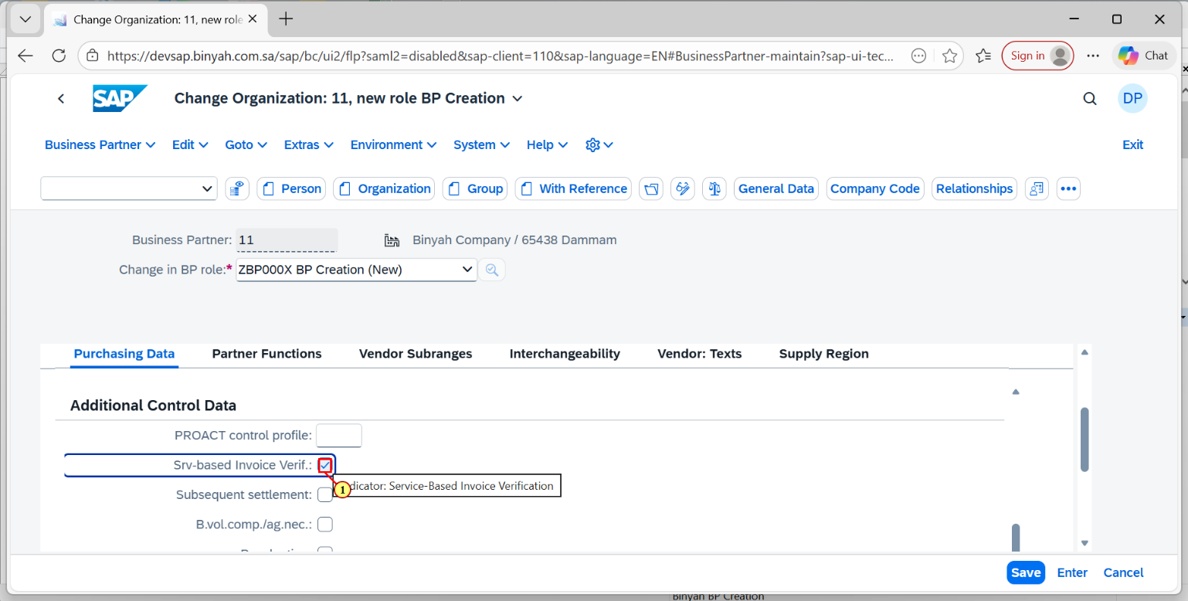

| Step | Action |
| --- | --- |
| (1) | Make sure it is "Ticked" like this. |

Change Organization: 11, new role BP Creation - Personal - Microsoft​ Edge

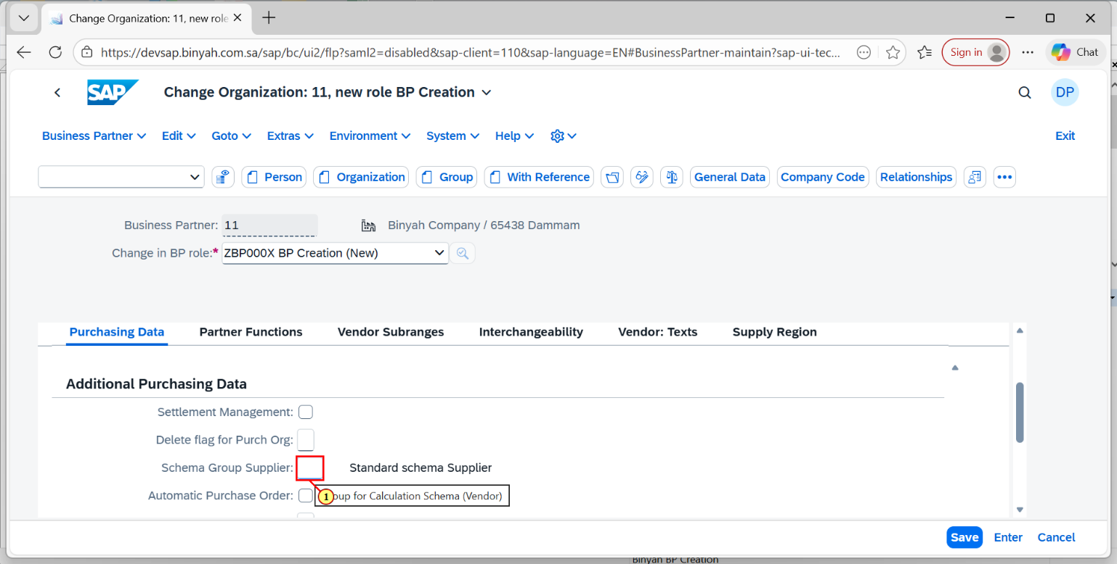

| Step | Action |
| --- | --- |
| (1) | Enter the Schema Group Supplier. |

Change Organization: 11, new role BP Creation - Personal - Microsoft​ Edge

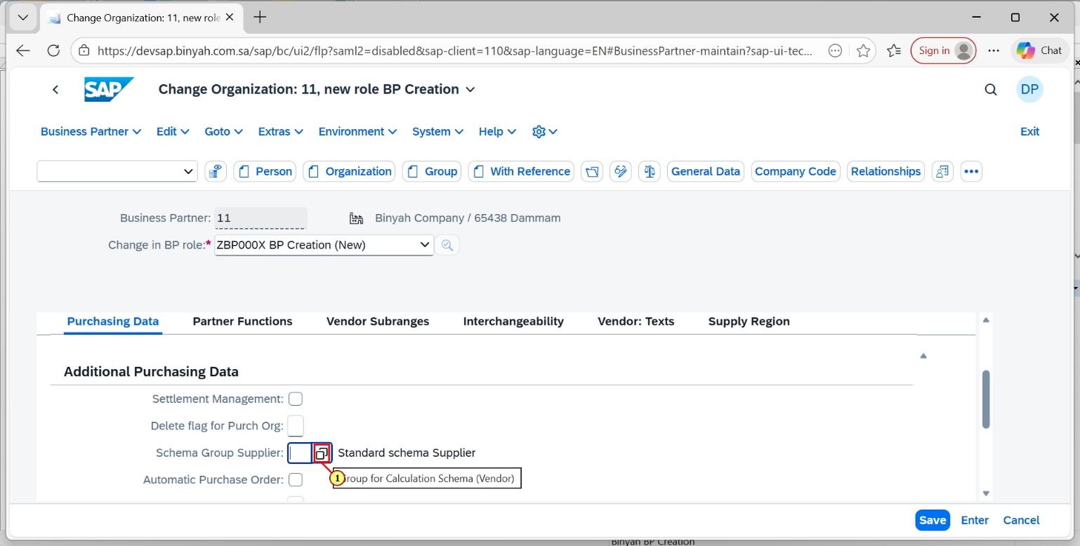

| Step | Action |
| --- | --- |
| (1) | Click on the search help icon. |

Change Organization: 11, new role BP Creation - Personal - Microsoft​ Edge

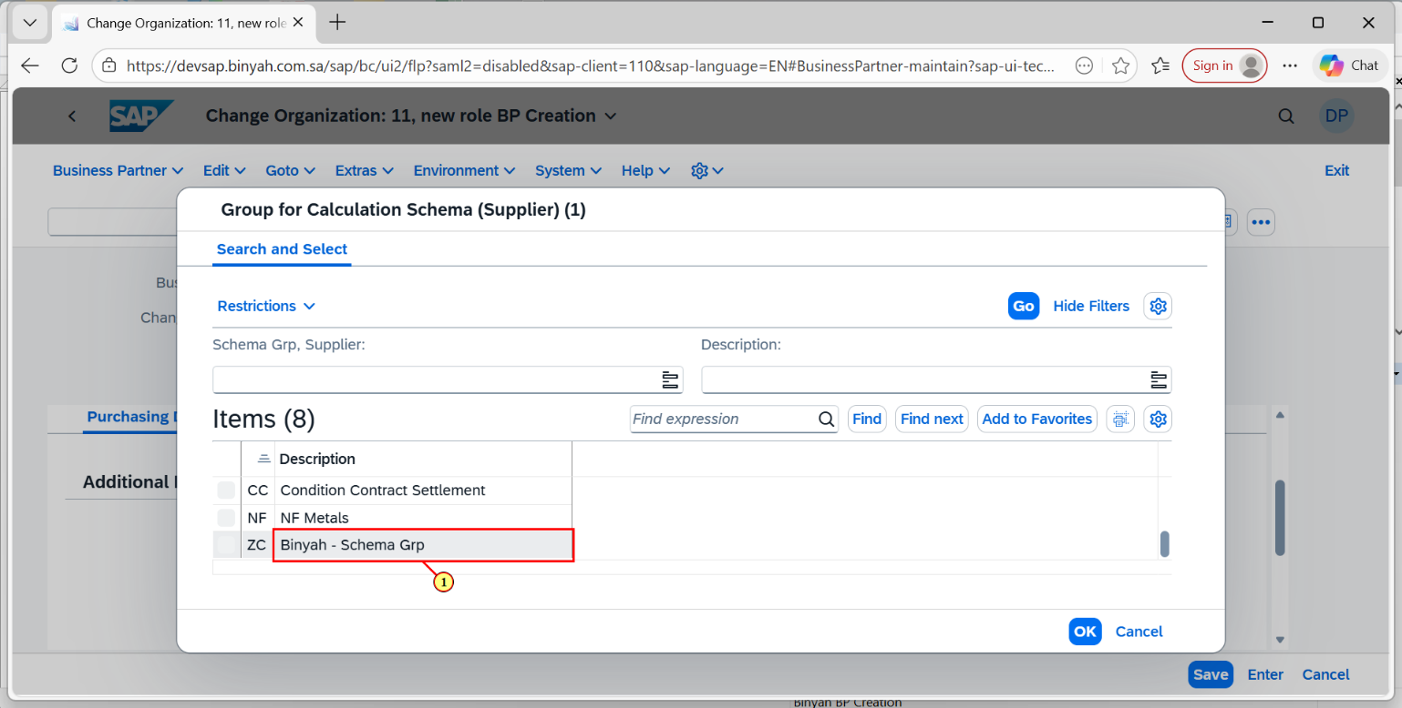

| Step | Action |
| --- | --- |
| (1) | Select the Item. |

Change Organization: 11, new role BP Creation - Personal - Microsoft​ Edge

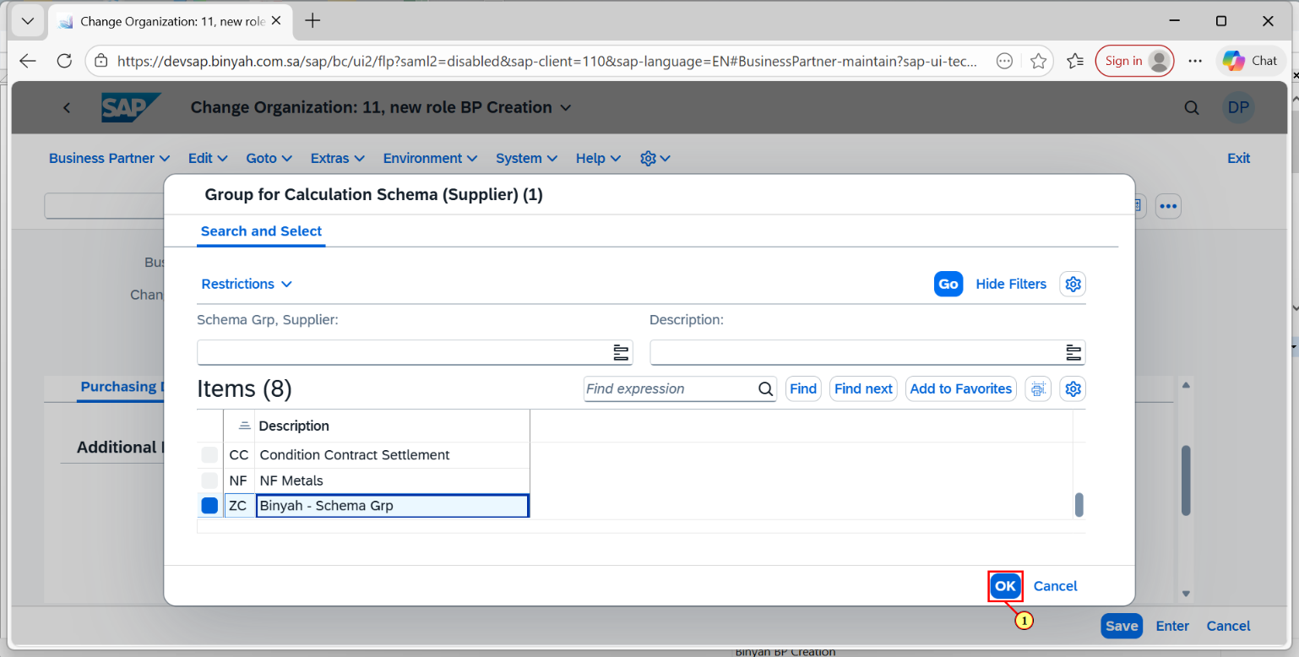

| Step | Action |
| --- | --- |
| (1) | Now click on "OK". |

Change Organization: 11, new role BP Creation - Personal - Microsoft​ Edge

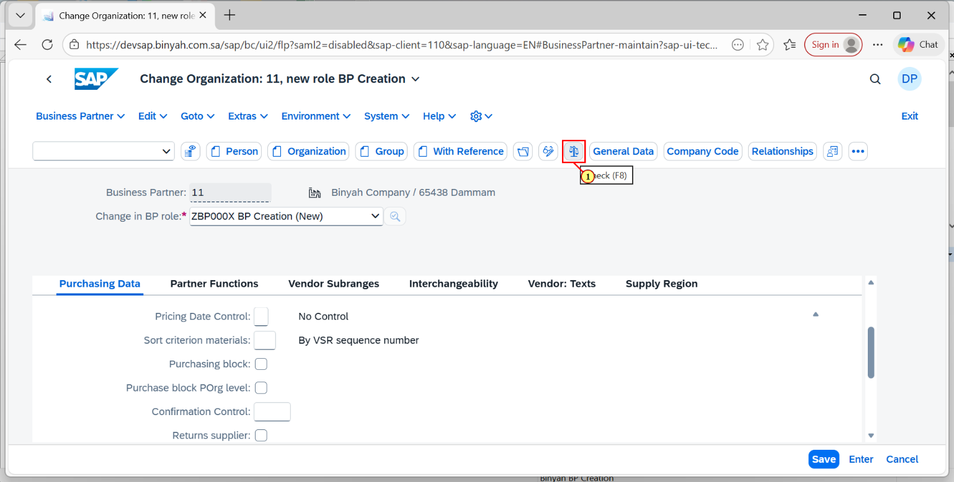

| Step | Action |
| --- | --- |
| (1) | Click on "Check" and after that click on "Save". |

Change Organization: 11, new role BP Creation - Personal - Microsoft​ Edge